**DCIP2D**

A Program Library for Forward Modelling and

Inversion of DC/IP Data over 2D Structures

VERSION 5.0

UBC–Geophysical Inversion Facility Department of Earth and Ocean Sciences University of British Columbia

Vancouver, BC

August 2011

***GIF***

UBC – Geophysical Inversion Facility 1988-2011

Table of Contents

***Package overview***

**Background****4**

**DCIP2D capabilities and limitations****6**

**Program library contents****6**

**References****7**

***Theoretical Background***

Introduction 8

Forward modeling 10

General methodology for inverting DC and IP data 14

Inversion of DC data 16

Inversion of IP data 18

References 20

*Elements*

Introduction 21

Obs.dat 21

potgrid.dat 25

FDmesh.dat 26

Topo.dat 28

Model.con(chg) 29

w.dat 30

active.dat 32

***Workflow***

Introduction 33

Understanding the data 34

Accumulating a priori information; building a reference model 34

Assigning uncertainties 35

Selection of model objective function 37

Evaluation of the results 39

***Executing Programs***

Introduction 43

DCIPF2D 43

DCINV2D 45

IPINV2D 50

***Examples***

Synthetic model 53

DC Examples 54

IP Examples 68

Depth of investigation 74

Large data set example 74

Field data example 77

Borehole examples 82

References 88







**DCIP2D manual:**



***Package overview***

**Content:**  Background | Capabilities | Program library contents | References |

### Background

DCIP2D is a program library for carrying out forward modelling and inversion of DC resistivity and induced polarization data in two dimensions. Version 1.0 of the code was first developed in 1992. That code, or a modified subsequent version, has been extensively used in mining and geotechnical communities and it has also been valuable as instructional software for learning about practical inverse theory. Improvements to the code however, have not kept pace with advances in optimization theory, scientific computing and computer architecture such as the prevalence of multi-core machines. To incorporate these advances, and renew DCIP2D to a state-of-the-art inversion code, we are releasing Version 5.0, which has been modified and fully parallelized using OpenMP to be used on computers with hyper-threading capabilities. The following is a list of modifications implemented in DCIP2D Version 5.0:

* **Electrodes can be located anywhere in the mesh**: Previous versions of the code required electrodes to be on mesh nodes. While convenient for simple arrays and few data, this added complications for working in regions if high topography and with non-uniform surveys such as Schlumberger.
* **Arbitrary electrode arrays**: All linear surface array data, or combinations thereof, can be inverted. For instance Wenner data and pole-dipole data can now be inverted.
* **Borehole data** can be inverted: In the new version of DCIP2D we have added the capability to incorporate borehole data. These can be inverted individually or in conjunction with surface array data.
* **Parallelization using OpenMP**: When many transmitters are used the computations can be distributed over multiple processers. The parallelization is invoked whenever a forward modeling is carried out or when **J**, the sensitivity matrix, is multiplied onto a vector which is required in the Conjugate Gradient (CG) solution.
* **Handling spatially large data sets**: Solution of the numerical optimization problem in the previous codes was carried out using a subspace technique. This worked well for typical exploration surveys. In some cases where the number of transmitters was very large, the subspace method had difficulties. In Version 5.0 we overcome this by solving the Gauss-Newton equations using a Conjugate Gradient (CG) method. The CG formulation is the suggested method of solution but we have left the original subspace solution methodology in the code. This will allow users to reproduce results obtained with the older codes. Many of the new features of the codes, for example the Huber and Ekblom norms, bound constraints, active and inactive cells work only with the CG approach.
* **Huber norm for data misfit**: Outliers in the data will negatively impact the performance of the inversion algorithm. This can be ameliorated by working with robust norms for data misfit. The Huber norm, which can range from L1to L2 has been implemented here.
* **Ekblom norm for the model objective function**: Typical L2 norms applied to the derivative components in the model objective function yield smooth bodies. Blocky bodies can be obtained by using an L1 norm (eg. Farquharson and Oldenburg, 1998). The Ekblom norm, which effectively ranges from L1 to L2 has been implemented here.
* **Incorporation of geologic information via bound constraints**: A priori knowledge about the background conductivity or chargeability can be incorporated via bound constraints. That is, each cell is restricted to have a model value **mjlow**<**mj**<**mjhigh**, where the bounds **mjlow** and **mjhigh** are prescribed by the user. The CG solution implements this through projected gradient techniques. This is faster than the interior point methodology used in the subspace method.
* **Incorporation of geologic information using the derivative terms in the model objective function**: The derivative terms in the model objective function can take the form:

**(1)**

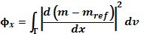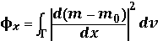

**(2)**

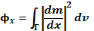

Similar equations can be written for the z derivatives. The difference is subtle but it has an important consequence in the inversion output. Consider a case where the a priori knowledge that a conductive overburden exists and a corresponding reference model has been generated. If the thickness of the overburden is known then the objective function with equation (1) should be used. The resultant model will have a boundary at the designated location. If the thickness is not known then equation (2) should be used. When this is done the reference model will appear only in the smallest model component ***s*** and the final model may show the discontinuity at a location different from that in the reference model. The capability of using the reference model in the derivative terms in these two ways is incorporated into Version 5.0. The choice of which objective function to use also arises with reference models generated from borehole information.

* **Incorporation of a priori information using active and inactive cells**: Considerable flexibility in constructing different types of solutions is afforded by being able to have certain cells "inactive". This can reduce the size of the inverse problem and also be used to incorporate a priori knowledge about the model. Inactive cells are used in the forward modeling but they are held fixed in the inversion. Again, there are choices to be made regarding whether the values of the inactive cells should, or should not, affect the neighboring cells. Different models are obtained from the two options.
* **Mesh builder**: The forward modelling requires that an underlying mesh be built and evaluated. An updated GUI is provided to help accomplish this job. The validity of the mesh is evaluated by computing the apparent resistivity for a homogenous halfspace.
* **Sensitivity Matrix**: A cumulative sensitivity matrix is generated. This is insightful for survey design and also it can be used as proxy for depth of investigation.
* **Depth of investigation**: The forward problem is numerically solved on a large domain but the data are only sensitive to a portion of that volume. Structure appearing at depth and outside the lateral extent of the data array is controlled only by the model objective function. As such it is best removed for final presentation. The useful region of investigation can be estimated using the DOI process (Oldenburg and Li, 1999) or by using the cumulative sensitivity analysis.
* **Selecting wave numbers**: Working in 2D requires that Maxwell's equations are solved in the wave number domain and a cosine transform is applied to obtain data in space. In previous codes the number and value of wave numbers were hardwired into the code. Default values are still generated but for highly unusual data sets there may be a reason to explore the dependence of solution accuracy with wave number selection.

### DCIP2D capabilities and limitations

#### Array types

All linear survey surface-array types, including non-standard or un-even arrays, as well as their combinations can be inverted. The GUI is mainly designed to handle the most commonly used array types and therefore it works well with dipole-dipole, pole-dipole, pole-pole and **Wenner** or **RealSection** arrays. Borehole data can be inverted but the user interface does not yet support borehole array types.

#### The Earth model

Inversion for a 2D model of the earth implies that data were gathered along a survey line at the surface. DCIP2D considers the subsurface in terms of a mesh of rectangular cells. Numerical accuracy in increased by using smaller cells but this also increases the size of the problem. here are usually at least three cells between electrode positions and the discretized volume extends well beyond the data area.

### Program library contents

The package that can be licensed includes the following components:

* **Executable programs** for performing forward modelling and inversion of 2D DC resistivity or induced polarization surveys. Both: the Windows and the Linux platforms are supported.
  + DCIPF2D.EXE: program to calculate DC resistivity and/or IP data based on a given model of the earth.
  + DCINV2D.EXE: program to invert 2D DC resistivity data
  + IPINV2D.EXE: program to invert 2D IP resistivity data
* **A graphical user interface** is supplied for the Windows platforms ***only***. Facilities include:
  + DCIP2D-GUI.EXE: a primary interface for setting up the inversion and monitoring progress,
  + DCIP2D-DATA-VIEWER.EXE: a utility for viewing raw data, error distributions, and for comparing observed to predicted data directly or as difference maps,
  + DCIP2D-MODEL-VIEWER.EXE: a utility for displaying resulting 2D models, and graphs of convergence behaviour.
  + DCIP2D-MODEL-MAKER.EXE: a separate utility for building synthetic 2D models and then running forward modelling to produce a synthetic data set.
* **Example data sets and exercises** can be provided upon request.

**References**

* Oldenburg D.W., and Li Y.  (1999), Estimating Depth of Investigation in DC resistivity and IP Surveys, Geophysics, vol. **64** , No.2, p. 403-416.
* Oldenburg, D.W, and Li, Y. (1994), Inversion of Induced Polarization Data*,* Geophysics, vol. **59** p. 1327-1341.
* Farquharson, C.G., Oldenburg D.W. (1998), Nonlinear inversion using general measures of data misfit and model structure, Geophysical Journal International, vol. **134**, p. 213-227.

**DCIP2D manual:**



***Theoretical Background***

**Content:**  Introduction | Forward modeling | General methodology | Inversion of DC data |Inversion of IP data | References

## 

## Introduction

This section presents theoretical background, numerical examples, and explanation for implementing the program library **DCIP2D**. This suite of algorithms, developed at the UBC-Geophysical Inversion Facility, is needed to invert DC potentials and IP responses over a 2-D earth structure. The manual is designed so that a geophysicist who has an understanding of DC resistivity and Induced Polarization field experiments, but who is not necessarily versed in the details of inverse theory, can use the codes and invert his or her data.

A typical DC/IP experiment involves inputting a current ***I*** to the ground and measuring the potential away from the source. In a time-domain system the current has a duty cycle which alternates the direction of the current and has off-times between the current pulses at which the IP voltages are measured. A typical time-domain signature is shown in figure 1. In this Figure,  is the potential that is measured in the absence of chargeability effects. This is the "instantaneous" value of the potential measured when the current is turned on. In mathematical terms this potential is related to the electrical conductivity  by equation (3):

 **(3)**

where the forward mapping operator  is defined by the equation (4):

 **(4)**

and also by appropriate boundary conditions. In equation (4)  is the electrical conductivity in Siemens/metre (S/m),  is the gradient operator, **I** is the strength of the input current in Amperes, and *rs* is the location of the current source. For typical earth structures , while positive, can vary over many orders of magnitude. The potential  in equation (4) is the potential due to a single current. This is the value that would be measured in a pole-pole experiment. If potentials from pole-dipole or dipole-dipole surveys are to be generated then they can be obtained by using equation (4) and the principle of superposition.

When the earth material is chargeable the measured voltage will change with time and reach a limit value which is denoted by  in figure 1. There are a multitude of microscopic polarization phenomena, which collaborate so that this final value is achieved but all of these effects can be consolidated into a single macroscopic parameter called "chargeability". We denote chargeability by the symbol . Chargeability is dimensionless, positive, and confined to the region [0,1).

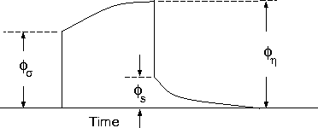  
Figure 1. Definition of the three potentials associated with DC/IP experiments.

To carry out forward modelling to compute  we adopt [Siegel's (1959)](http://www.eos.ubc.ca/ubcgif/iag/sftwrdocs/dcip2d/dcip2d-manual/ref.html) formulation which says that the effect of a chargeable ground is modelled by using the dc resistivity forward mapping  but with the conductivity replaced by . Thus:

 **(5)**

or

 **(6)**

The IP datum, which we refer to as “apparent chargeability”, is defined by

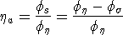 **(7)**

or

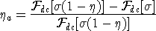 **(8)**

Equation (8) shows that the apparent chargeability can be computed by carrying out two DC resistivity forward modelling routines with conductivities  and **(1- )**. Note that in this definition apparent chargeability is dimensionless and, in the case of data acquired over an earth having constant chargeability **0** , we have **a = 0** .

The field data from a DC/IP survey are a set of N potentials (ideally  but usually ) and a set of N secondary potentials  or a quantity that is related to . The goal of the user is to utilize these data to acquire quantitative information about the distribution of the two physical parameters of interest: conductivity *(x,y,z)* and chargeability *(x,y,z)* .

The distribution of conductivity and chargeability in the earth can be extremely complicated. Assuredly earth structure is 3D but for the DC/IP codes developed here we restrict ourselves to 2D structures and assume that the survey has been carried out along a traverse which is perpendicular to strike. The cross-section of the earth is divided into rectangular prisms each having a constant value of conductivity and chargeability.

## Forward modeling

The forward modelling for the DC potentials and IP apparent chargeabilities and secondary potentials is accomplished using a finite difference technique to solve equation (4). The program which performs this calculation is DCIPF2D. To illustrate the DC resistivity forward modelling algorithm we generate synthetic data that would be acquired over the 2D conductivity structure shown in [figure 2a](#FIG2" \t "fig2). The model region consists of a 10 meter thick overburden having conductivity of 0.1 mS/m on the left and 2 mS/m on the right. A V-shaped valley is cut out to simulate the surface topography. Two conductors are buried in the underlying background of 1 mS/m. On the left, a dipping conductor having a dip of 135o and conductivity of 100 mS/m is buried at a depth of 20 m to the top. On the right, a 50 meter long, 20 meter thick conductive block of 100 mS/m is buried at a depth of 25 meters. Rather than keep the model as discrete blocks we have attempted to make it more geologically realistic by applying a smoothing filter to the model. The model is divided into 48 cells in the x-direction and 27 cells in the z-direction including a total of 1296 cells. The finite difference mesh is shown in figure 2b. In the survey, surface electrodes are located every ten meters in the interval *x* = (-100, 100) meters. We compute the potential differences from a pole-dipole array with the potential electrodes on the right. Our designation for this is PDR (Potential Dipole Right). There are 19 possible current electrode locations and we record the data for each electrode to a maximum n-spacing of 8. The observed data set consists of 124 potential difference values. It is our intention to use these data as input to an inversion. In order to make them more realistic we contaminate each datum by adding Gaussian noise having a standard deviation equal to 5% of the true potential. The apparent resistivity pseudo-section is shown in figure 3b. That figure can be compared with the conductivity model in figure 3a. There is some manifestation of the horizontal conductive block but much of the conducting "pant-leg" seen is really the result of the near surface variation of conductivity and topography.

The forward modelling for the IP data is also performed with the program DCIPF2D. To calculate IP data, the program performs two DC forward modelling routines and the IP data are generated by the operations indicated in equation (8). For a synthetic example we choose the chargeability model in figure 4a. It consists of a chargeable layer at the surface with  = 0.05 and two chargeable blocks of = 0.15 at depth. The 124 IP data collected in the survey are also contaminated with Gaussian noise having a standard deviation equal to 5% of the accurate value of the apparent chargeabilites, plus an additional floor noise having a standard deviation of 0.001. The apparent chargeabilities are plotted as percentages in pseudo-section form in figure 4b. There is little manifestation of the chargeable block which is the target for this inversion but the user is faced with the difficulty of deciding how much of the high chargeability feature sloping downward to the left is the result of a pant leg from the termination of the surface chargeable block.

In Version 5.0 we include the option to calculate IP data by multiplying the sensitivity matrix J by the chargeability provided by user. That is, we forward model with the linear equations that will be used for the inversion. The chargeability in this case can have arbitrary units. The forward modeled data are calculated as

**(9)**



Where dIP is the IP data, dDC is the DC data, J is the sensitivity matrix for the IP problem. Forward modeling using equation (9), which is further explained in the section “Inversion of IP data” later in the document.

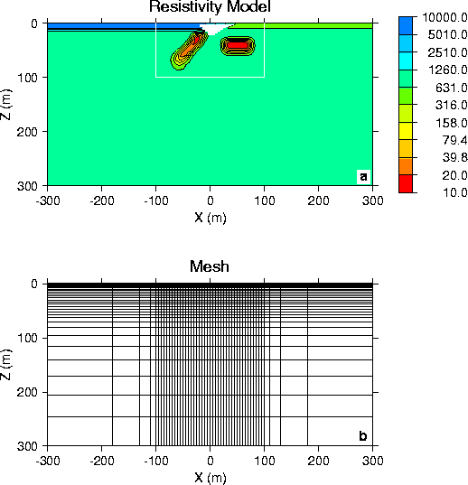

Figure 2. The synthetic model consists of two conductors buried in a uniform halfspace overlain by an overburden of variable conductivity. A V-shaped valley simulates the surface topography. The top panel shows the entire model used in the forward modelling. The region of interest is outlined by the white lines, but padding cells are added so that the correct boundary conditions can be applied during the forward modelling. The bottom panel shows the finite different mesh used in the modelling.

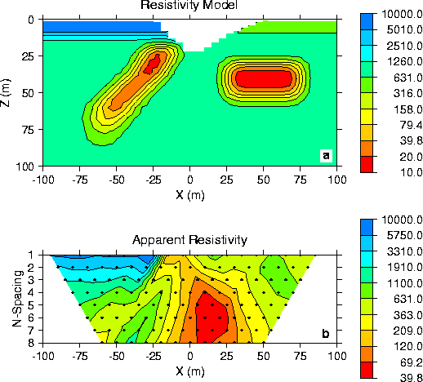

Figure 3. Panel (a) is the conductivity model, which is the same as the region outlined in Figure 2(a). Panel (b) is the apparent resistivity pseudo-section measured using a pole-dipole array with a=10 m and n=1,8. The data have been contaminated by Gaussian noise.

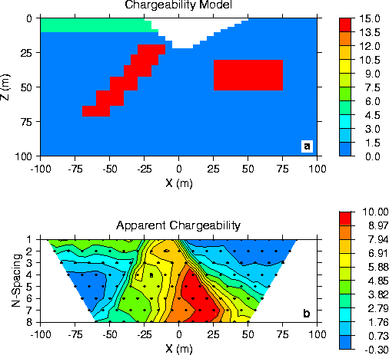

Figure 4. Panel (a) is the chargeability model associated with the conductivity in Figure 3(a). Panel (b) is the apparent chargeability pseudo-section measured using a pole-dipole array with a=10 m and n=1,8. The data have been contaminated by Gaussian noise.

## 

## General methodology for inverting DC and IP data

The computing programs outlined in this manual solve two inverse problems. In the first we invert the DC potentials  (or equivalently the data in figure 3b) to recover the electrical conductivity *(x,z)*. This is a nonlinear inverse problem that requires linearization of the data equations and subsequent iteration steps. Next, we invert the IP data in figure 4b to recover the chargeability *(x,z)*. Because chargeabilities are usually small quantities ( < *0.3*) it is possible to linearize equation (8) and derive a linear system of equations to be solved. Irrespective of which data set is being inverted however, we basically use the same methodology to carry out the inversions.

To outline our methodology it is convenient to introduce a single notation for the "data" and for the "model". We let **d** = *(d1,d2,...,dN)* denote the data. So *di* could be the *i*th potential in a dc resistivity data set or the *i*th apparent chargeability in an IP survey. Let the physical property of interest be denoted by the symbol *m*. The quantity *mi* can denote the conductivity or chargeability for the *i*th cell. For the inversion we choose *mi* = ln( *i* ), when inverting for conductivities and *mi* = *i* when reconstructing the chargeability section.

The goal of the inversion is to recover a model vector **m** = *(m1,m2,...,mM),* which acceptably reproduces the N observations **dobs** = *(d1obs,d2obs,...,dNobs)*. Importantly, the data are noise contaminated, therefore we don't want to fit them precisely. A perfect fit in our case would be indicative, that incorrect earth model is recovered, as some features observed in the constructed model would assuredly be artifacts of the noise.

Alternatively, if we fit the data too poorly then information about the conductivity that is coded in the data will not have been recovered. Our objective therefore is neither to underfit, nor overfit the data. Rather, we want to find a model which reproduces the data only to within an amount that is justified by the estimated uncertainty in the data. To accomplish this we introduce a global misfit criterion

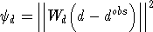 **(10)**

where **W**d is a datum weighting matrix. In this work we shall assume that the noise contaminating the *j*th observation is an uncorrelated Gaussian random variable having zero mean and standard deviation *j*. As such, an appropriate form for the *N×N* matrix is . With this choice, *d* is the random variable distributed as chi-squared with *N* degrees of freedom. Its expected value is approximately equal to *N* and accordingly, *d*\*, the target misfit for the inversion, should be approximately equal to this value.

Earth conductivity distributions are complex. To allow maximum flexibility to produce a model of arbitrary shape it is important that *M*, the number of cells representing the model, is large. In our inversions *M* will almost always be greater than *N*, the number of data. The inverse problem therefore reduces to finding a set of *M* parameters using only *N* data constraints under the condition that *M,N*. Clearly the solution is no unique and this non-uniqueness represents the principle obstacle for obtaining unambiguous information about earth structure from the observations.

Any inversion algorithm (if it works) will produce a model, which reproduces the data. But there are infinitely many possible models. So which one does the algorithm produce? It is not good practice to let the program make a random selection. Rather, a responsible approach is to direct the inversion algorithm to produce a model that is geologically reasonable and is constrained by additional information if such information is available. This can be implemented by formulating a "model objective function" which, when minimized, produces a model with desirable characteristics. The critical aspect of the inversion is therefore to form the model objective function which we characterize by *m*. To do this, the user must ask the question "what type of model is desired?" Should the model be smooth, should it be blocky? Is there a reference or background model that the constructed model should emulate? If there is a reference model, is it better known in some places than others so that the constructed model should be close to the reference model in certain locations but can depart from our preconceived ideas in other areas? Whatever the answer to these questions, a guiding philosophy should always be to find a model which (in some sense) is "as simple as possible". The non-uniqueness inherent in the inversion generally means that we can generate models which are arbitrarily complicated. We cannot however, make models that are arbitrarily simple. For example a halfspace will generally not reproduce data acquired from a geophysical survey.

In the inversion algorithms in DCIP2D our choice for the objective function *m* is guided by a desire to find a model which has minimum structure in the vertical and horizontal directions and at the same time is close to a reference model *m*0. To accomplish this we minimize a discretized approximation to

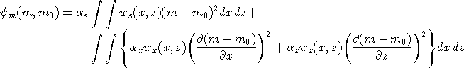  **(11)**

In equation (11) the functions *ws ,wx ,wz* are specified by the user and the constant *s* controls the importance of closeness of the constructed model to the reference model *m*0 and *x* , *z* control the smoothness of the model in the two directions. Varying the ratio *x* / *z* allows the construction of models that are smoother, thus more elongated, in either x- or z-direction. The discrete form of equation (11) is the following:

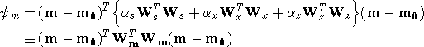 **(12)**

If *ws ,wx ,wz* are set equal to unity then **W**s is a diagonal matrix with elements , where *x* is the length of the cell and *z* is its thickness, *Wx* has elements  where *dx* is the distance between the centers of horizontally adjacent cells, and *Wx* has elements  where *dz* is the distance between the centers of vertically adjacent cells.

The inverse problem is now properly formulated as an optimization problem:

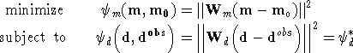 **(13)**

In equation (13) **m0** is a starting model and **Wm** is a general weighting matrix which is designed so that a model with specific characteristics is produced. The minimization of *m* yields a model that is close to **m0** with the metric defined by **Wm** and so the characteristics of the recovered model are directly controlled by these two quantities. If the data errors are Gaussian and their standard deviations have been adequately estimated then **Wd** can be set to and the target misfit should be *d*\* = *N*.

## Inversion of DC data

The inversion of the apparent resistivity data shown in figure 3b is carried out using the program DCINV2D. In performing this inversion we keep the same mesh for the inverse problem as for the forward problem. This means that we will find conductivities for the 1296 cells so that the 124 observations are adequately fit. In the synthetic modelling we know the standard deviation of the data errors and therefore an appropriate target value for the misfit is *d*\*=124.

Our model objective function is of the form indicated in equation (12). For this particular inversion we have set *ws ,wx ,wz* equal to unity and have chosen *s*=.001, *x*=1.0, *z*=1.0 and *m*0=1 mS/m.

The inversion method requires linearizing the data equations and iterating. The details of the inversion can be found in [Oldenburg et al (1993)](http://www.eos.ubc.ca/ubcgif/iag/sftwrdocs/dcip2d/dcip2d-manual/ref.html). At each iteration, a system of equations is solved using generalized subspace or Conjugate gradient (CG) techniques. The inversion begins with a halfspace of conductivity 1 mS/m and at every iteration we ask for a 50% decrease in the misfit objective function until the target misfit *d* = *N* is achieved. Once the target misfit has been obtained, the iterations continue in an attempt to reduce the model objective function and hence reduce unnecessary structure while keeping the misfit at the desired target value. For the example presented below, the desired misfit *d* =124 is achieved by iteration 12 but a few more iterations are carried out until no further decrease in the model objective function is obtained. The model obtained at iteration 20 is shown in figure 5b. It compares favorably with the true input model in figure 5a. The surface variation is well defined and so are the conductive anomalies at depth. The conductivities toward the bottom of the model approach that of the halfspace reference model. This is the expected result. If the data are insensitive to certain regions of the model domain then the inversion will make those regions have conductivities close to the reference model as this will be most effective in reducing the value of the model objective function. To evaluate the benefits of the inversion, the reader should compare the constructed model in figure 5b with the apparent resistivity pseudo-section in figure 3b.

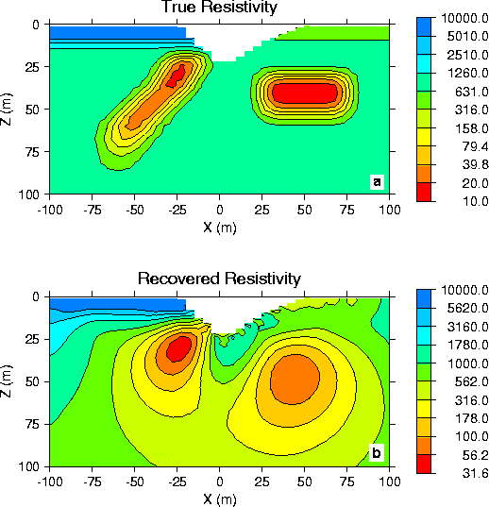

Figure 5. Comparison of the true resistivity model (a) with the recovered resistivity model (b).

## Inversion of IP data

To invert the IP data in figure 4b we first linearize equation (7). Let *i* and *i* denote the chargeability and electrical conductivity of the *i*th cell. Linearizing the potential  about the conductivity model  yields:

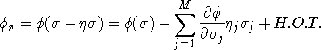 **(14)**

Substituting into equation (7) yields:

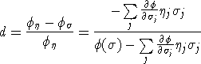 **(15)**

This can be approximately written as

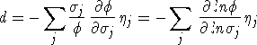 **(16)**

Therefore, the *i*th datum is:

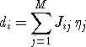 **(17)**

where

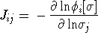 **(18)**

is the sensitivity matrix. Our inverse problem is formulated as:

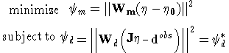 **(19)**

where *d*\* is a target misfit. In reality the true conductivity  is not known and so we must use the conductivity found from the inversion of the DC resistivity data to construct the sensitivity matrix elements in equation (18).

The functional in equation (19) can be minimized directly but we need to ensure that the recovered chargeability is positive. In the inversion of the DC potentials to recover the conductivity we ensured positivity by working with ln() as the model in the inversion and applying the model norm to this quantity. This is justified, since conductivity varies over many orders of magnitude and it is the variation of conductivity that is diagnostic of earth structure. Intrinsic chargeability is confined to the region [0,1). Moreover, we are not generally interested in the variation of chargeability in the range between zero and some small number (e.g. 0.01). Working with logarithmic values however, puts undue emphasis on these small values. An efficient method by which to solve the linear inverse problem with positivity constraints is through a non-linear mapping of variables. More details of the IP inversion algorithm can be found in [Oldenburg and Li (1994)](http://www.eos.ubc.ca/ubcgif/iag/sftwrdocs/dcip2d/dcip2d-manual/ref.html).

The 124 IP data shown in figure 4b are subjected to the inversion. The model norm objective function is identical to that used for the DC resistivity inversion except that the reference model has been set equal to zero. A zero reference model is likely to be appropriate for most IP inversions. The resultant chargeability model which has the desired misfit of 124 and was obtained after 11 iterations, is shown in figure 6b. There has been an excellent recovery of both the chargeable surface layer and the subsurface blocks. Some roughness in the surface block is noticed but the amplitude range of .045 to 0.07 brackets the true value of 0.05. The locations of the chargeable blocks have been well reproduced and the maximum amplitude of the model is consistent with the true value. However, the centre of the chargeable block on the right is slightly deeper than the true position, and the smooth bottom of the recovered anomaly has accentuated this appearance. Evaluation of the benefits of the inversion can be obtained by comparing figure 6b with the data in figure 4b. We also note that this good recovery was obtained even though the sensitivities for the IP inversion were generated from the recovered conductivity in figure 5b rather than the true conductivity in figure 5a.

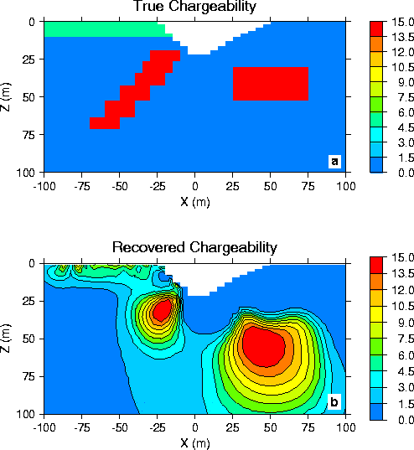

Figure 6. Comparison of the true chargeability model (a) with the recovered chargeability model (b).

## References

Siegel, H. O. (1959). Mathematical formulation and type curves for induced polarization, *Geophysics*, **24**, 547-565.

Oldenburg, D. W. and Li, Y. (1994). Inversion of induced polarization data, *Geophysics*, **59**, 1327-1341.

Oldenburg, D. W., McGillivary, P. R., Ellis, R. G. (1993). Generalized subspace method for large scale inverse problems, *Geophys. J. Int.*, **114**, 12-20.

Li, Y., and Oldenburg, D.W. (2000). Incorporating geologic dip information into geophysical inversions, Geophysics, 65 , #1, pp 148-157.

Oldenburg, D.W., and Li, Y.  (1999). Estimating Depth of Investigation in DC resistivity and IP Surveys, Geophysics, 64 , #2, 403-416.

**DCIP2D manual:**



***Elements***

**Content:**  Introduction | obs.dat | potgrid.dat | fdmesh.dat |topo.dat | model.con(chg) | w.dat |active.dat |

## Introduction

#### The DCIP2D library consists of three major programs:

1. DCIPF2D: performs forward modelling for DC and IP data
2. DCINV2D: inverts DC potentials to recover a conductivity model
3. IPINV2D: inverts IP data to recover a chargeability model

Each of the above programs requires input files as well as the specification of parameters in order to run. However, some files are used by a number of programs. Before detailing the run procedures for each of the above programs we first present information about these general files.

#### General Files for DCIP2D Programs

There are 7 general files which are used in DCIP2D. These are:

1. obs.dat: contains the observations
2. potgrid.dat: contains the electrode locations for the survey
3. fdmesh.dat: contains the finite difference mesh for the 2D modelling and inversions
4. topo.dat: contains the topographic data
5. model.con: contains the cell values for the conductivity model
6. model.chg: contains the cell values for the chargeability model
7. w.dat: contains special weightings which alter the type of model produced in the inversions.

## Obs.dat

This file contains the observed measurements and the associated electrode locations. Both potential data and apparent chargeability data are stored in the same format. This will be the format of all the data files that are output from DCIPF2D, and are input to DCINV2D and IPINV2D.

It is assumed that the survey is carried out either along a line in the x-direction, which is perpendicular to geologic strike or along a borehole. In case of surface geometry, it is assumed that all current and potential electrodes are located on this line and that all electrodes are on the surface. In this case the coordinates of any electrode are completely specified by its location along the x-axis., while the z-coordinate of the electrode is assumed to coincide with the topography at location X. Programs in the DCIP2D package will automatically place the electrodes on the surface according to the topography. If the file topo.dat is not supplied, all electrodes will be at *z*=0. When the topography is specified, the electrode will be placed on the topographic surface that is discretized onto the finite difference mesh according to file topo.dat.

In the borehole case, the Z coordinates are provided separately in the obs.dat file and can be located below surface, along the borehole. Any surface/borehole combination of electrodes is allowed in DCIP2d V.5.0 . The obs.dat file can have two different formats; the "standard" format and the "common-current" format. The type of format chosen to store the data does not make any difference to the DCIP2D programs and so the choice is determined by the user's preference. At the beginning of execution, the programs check to see which format is used. The output files will be stored in the same format. 

#### (a) Standard Format:

In this format, each observation record is stored in one line. Each record consists of six columns specifying the X locations of the current electrodes (*XA, XB*) and potential electrodes (*XM, XN*), data and standard deviation (optional). The data records can be arranged in any order. The file structure for the standard format **obs.dat** is as follows:

COMMENT

IPTYPE=1

XA1 [ZA1] XB1 XM1 XN1 VAL1 [ERR1]

XA2 XB2 XM2 XN2 VAL2 ERR2

XA3 XB3 XM3 XN3 VAL3 ERR3

:

COMMENT

Any comment. This line is ignored by DCINV2D if the data is in “Standard” format

IPTYPE

Only used for IP data inversion. IPTYPE=1 will indicates type of IP data is apparent chargeability IPTYPE=2 indicates that type of data is secondary potentials.

NDAT

Total number of data in the file (header)

XAi, XBi

X positions (in metres) of the current electrodes used to measure the datum VALi. When current is input by a dipole, *XB* will be taken as the position of the negative current electrode. When current is input by a pole, *XB* is not used, but the input field must remain.

ZAi, ZBi

Z positions (optional) of the current electrodes used to measure the datum VALi. Used in borehole data files only.

XMi, XNi

X positions (in metres) of the potential electrodes used to measure the datum VALi. When potential is measured by a dipole, *XN* will be taken as the position of the negative potential electrode. When potential is measured by a pole, *XN* is not used, but the input field must remain.

ZMi, ZNi

Z positions (optional) of the potential electrodes used to measure the datum VALi. Used only with borehole measurements.

VALi

Value of observed datum. The potential measurements must be measured value in Volts for potential, or a dimensionless real number (not percentage) for apparent chargeability. (**The potential value is always normalized to unit current amplitude.**) There are four types of IP data generally in use; two gathered in the time domain and two gathered in the frequency domain. For small chargeabilities, as is nearly always the case for earth materials, all data types can be used as input for inversion, and resulting models will have chargeabilities in the same units.

ERRi

Standard deviation of the datum VALi. This is an absolute value and should not be specified as a percentage. This value should always be positive. If the first datum does not have an error field (or the error field is commented out by placing a "!" before it), the default errors for the entire data set will be calculated from the data.

If the default standard deviation is requested, it will be calculated from the data using the following rules:

* **DC**: ERRi = 0.05 × | *i* | + *nmax* , where *nmax* is the potential at the maximum electrode separation averaged over 5 adjacent stations.
* **IP**: ERRi = 0.05 × | *ai* | + *amin* , where *amin* is the estimated standard deviation of the background apparent chargeabilities in the data set.

In the borehole case, the standard format is not allowed

#### (b) Common-current Format:

In this format, data are grouped by the current electrode locations. For each current (XA, XB), there should be N lines containing the potential electrode locations, data and standard deviation (optional). The file structure for the "common-current" format **obs.dat** is as follows:

COMMON_CURRENT

NCUR

XA1 XB1 N1

XM1 XN1 VAL1 ERR1

XM2 XN2 VAL2 ERR2

:

XA2 XB2 N2

:

The common-current format can be also used for borehole measurements. In this case, all Z locations of the current and potential electrodes also must be specified as following:

COMMON_CURRENT

NCUR

XA1 ZA1 XB1 ZB1 N1

XM1 ZM1 XN1 ZN1 VAL1 ERR1

XM2 ZM2 XN2 ZN2 VAL2 ERR2

:

XA2 ZA2 XB2 ZB2 N2

:

ERRi

Type of data format (header).

NCUR

Number of current locations (header).

XAn, XBn

X positions of the *n*th current electrodes in meters.

ZAn, ZBn

Z positions of the *n*th current electrodes in meters (for borehole data only).

Nn

Number of measurements of potential corresponding to source location XAn and XBn.

XMi, XNi

X positions of the *i*th potential electrodes in metres for a given source location. There must be *Nn* potential locations for the *n*th source location.

ZMi, ZNi

Z positions of the *i*th potential electrodes in metres for a given source location (for borehole data only).

VALi

Measured value in Volts for potential, or a dimensionless real number (not percentage) for apparent chargeability at the *i*th potential electrodes. (**The potential value is always normalized to unit current amplitude.**) There are four types of IP data generally in use; two gathered in the time domain and two gathered in the frequency domain. For small chargeabilities, as is nearly always the case for earth materials, all data types can be used as input for inversion, and resulting models will have chargeabilities in the same units.

ERRi

Standard deviation of the datum VALi. This is an absolute value and should not be specified as a percentage. This value should always be positive. If the first datum does not have an error field (or the error field is commented out by placing a "!" before it), the default errors for the entire data set will be calculated from the data.

#### Examples of the obs.dat file:

The following examples correspond to pole-dipole acquisition. Note that the electrode configuration is the same as that in the potgrid.dat example. Example-1 , and example 4 have user-supplied errors, while example-2 and example-3 cause the inversion program to calculate the default errors. 

**Example-1:** Data errors are supplied by the user in column-6. ("Standard" format)

   UBC-GIF DC Model

-100.00   -100.00    -80.00    -70.00   8.47942E+00   4.31066E-01

   -100.00   -100.00    -70.00    -60.00   2.71912E+00   1.28015E-01

   -100.00   -100.00    -60.00    -50.00   1.14801E+00   5.61510E-02

   -100.00   -100.00    -50.00    -40.00   6.27136E-01   2.99415E-02

    -90.00    -90.00    -80.00    -70.00   4.98173E+01   2.66027E+00

    -90.00    -90.00    -70.00    -60.00   8.77796E+00   4.74392E-01

    -90.00    -90.00    -60.00    -50.00   2.80881E+00   1.36039E-01

    :

**Example-2:** Default errors are used. Column-6 is blank. ("Standard" format). IP data type 1 (chargeabilities).

UBC-GIF IP Model

IPTYPE=1

-100.00   -100.00    -80.00    -70.00   8.47942E+00

   -100.00   -100.00    -70.00    -60.00   2.71912E+00

   -100.00   -100.00    -60.00    -50.00   1.14801E+00

   -100.00   -100.00    -50.00    -40.00   6.27136E-01

   -100.00   -100.00    -40.00    -30.00   2.88175E-01

    -90.00    -90.00    -80.00    -70.00   4.98173E+01

    -90.00    -90.00    -70.00    -60.00   8.77796E+00

     :

**Example-3:** default errors are used. The column-4 of the first datum is commented out by an "!". This allows the user to override any previously assigned errors. ("Common-current" format)

COMMON_CURRENT

   17

   -100.00   -100.00    3

    -80.00    -70.00   0.847942E+01  ! 0.431066E+00

    -70.00    -60.00   0.271912E+01  ! 0.128015E+00

    -60.00    -50.00   0.114801E+01  ! 0.561510E-01

    -90.00    -90.00    4

    -80.00    -70.00   0.498173E+02  ! 0.266027E+01

    -70.00    -60.00   0.877796E+01  ! 0.474392E+00

    -60.00    -50.00   0.280881E+01  ! 0.136039E+00

    -50.00    -40.00   0.110303E+01  ! 0.559810E-01

:

**Example-4:** Borehole Z -locations and user-assigned errors are used. ("Common-current" format). Please note that for borehole configuration there must be a header on the common-current file so it does not get mixed with the regular non-borehole input configuration.

COMMON_CURRENT

40

10950 500 10950 500 1

10900 497 10800 497 0.371528 0.0186764

11050 493 11050 493 2

10900 485 10800 485 0.147833 0.00749165

11000 480 10900 480 0.501446 0.0251723

11050 493 11050 493 3

:

## potgrid.dat

This file specifies the electrode positions for the survey and is used only in forward modelling program DCIPF2D. The formats of this file are identical to those used in obs.dat file, except that the data (VALi) and error (ERRi) columns are removed. Both standard and common-current formats can be used. The output data file produced by DCIPF2D will be in the same format as the input potgrid.dat file. In DCIPF2D V.5.0 there’s an added capability to simulate secondary potentials in case with IP data. The IP data type has to be specified in the header of potgrid.dat. IP data type 1 means that simulation for chargeabilities will be carried out, while IP data type 2 means that the secondary potentials will be calculated. A combination of chargeabilities and secondary potential data can be simulated in a single forward model.

#### Examples of potgrid.dat file:

The following two examples illustrate the potgrid.dat file in two formats and contain the electrode geometry for the example data file shown for obs.dat. "Standard" format (surface data only) IP data type = 1 (simulate chargeabilities); IP data type = 1 (simulate secondary potentials):

##### "Standard" format (mixed IP data types):

UBC-GIF IP Model

IPTYPE=1

-10000.00 -10000.00 -10080.00 -10070.00

-10000.00 -10000.00 -10070.00 -10060.00

-10000.00 -10000.00 -10060.00 -10050.00

-10000.00 -10000.00 -10050.00 -10040.00

IPTYPE=2

-10000.00 -10000.00 -10040.00 -10030.00

-10090.00 -10090.00 -10080.00 -10070.00

:

##### "Common-current" format (surface data only):

COMMON_CURRENT

17

-10050.00 -10050.00 4

-10080.00 -10070.00

-10070.00 -10060.00

-10060.00 -10050.00

-10050.00 -10040.00

-10090.00 -10090.00 4

-10080.00 -10070.00

-10070.00 -10060.00

-10060.00 -10050.00

-10050.00 -10040.00

:

"Common-current" format (borehole):

COMMON_CURRENT

40

10950 500 10950 500 1

10900 497 10800 497

11050 493 11050 493 2

10900 485 10800 485

11000 480 10900 480

11050 493 11050 493 3

10900 485 10800 485

11000 480 10900 480

:

## FDmesh.dat

This is the file used to define a finite difference mesh for 2D modelling and inversion. In the file, the x-z plane is divided into a rectangular grid. By convention, the z-axis is positive down. fdmesh.dat has the following structure:

NLX

X0 X1 NINTX1

X2 NINTX2

:

XNLX NINTXNLX

NLZ

Z0 Z1 NINTZ1

Z2 NINTZ2

:

ZNLZ NINTZNLZ

NLX

Number of segments used to define the horizontal partitioning.

Xn

The X coordinate of a boundary of a segment.

NINTXn

Number of cells in the segment bounded by Xn-1 and Xn.

NLZ

Number of segments used to define the vertical partitioning

Zn

The Z-coordinate of a boundary of a segment

NINTXn

Number of cells in the segment bounded by Zn-1 and Zn.

The mesh can be designed by considering it as consisting of a core portion representing the region of interest and a padding zone which ensures that the boundary conditions in the finite difference modelling are handled correctly. In the core portion, the horizontal mesh is mainly controlled by the experiment grid on which to collect the data, so the mesh partition in this region is usually uniform given that the data are collected at constant intervals and the cell width is an integer fraction of the station spacing (or dipole length of the array).

Generally, at least three cells are recommended between adjacent stations (i.e., per dipole length). In the presence of topography, one might use a finer partitioning in sections where the topographic relief changes rapidly. This helps to better approximate the topographic surface using the finite difference mesh.

In the presence of surface topography, the top of the finite difference mesh corresponds to the highest point on the surface (see also the description of topo.dat). Since the current sources are all on the surface of the earth, the vertical mesh has thicknesses which generally increase with depth. The cell thickness should be small near the surface and increase slowly in the upper region that is within the array's depth of investigation. Finer partitioning can be used at a depth where there is rapid change in the conductivity for forward modelling or where one might expect anomalous structures in the inversion. The maximum depth for the mesh should be considerably larger than the depth of investigation provided by the survey. The thickness of the cells, especially near the surface, should be determined in reference to the horizontal partitioning so that the cells do not have an extremely large aspect ratio (width divided by thickness). Cells with extreme aspect ratio tend to degrade the quality of the forward solution and they can also cause undesirable abrupt changes in the inversion results. It is good practice to keep the aspect ratio of cells less than 5.

Once the core mesh is designed, a set of padding cells is required to extend the mesh horizontally. Three to five cells whose width progressively increases by a factor of two to three provide sufficient extension so that the boundary conditions are adequately handled.

It is good practice to generate the mesh and perform a forward modelling using a uniform conductivity model. If the mesh has been properly designed then the apparent conductivities obtained from the forward modeled responses should not deviate from the true conductivity by more than a few percent. If the deviation is larger, the mesh should be modified and the halfspace test performed again. This test is valid when there is no topography. However, a mesh designed properly for a model with topography should pass the halfspace test when the mesh is used alone without topography.

#### Example of fdmesh.dat file:

A 48×27 mesh with the region of interest being X=[-100,100]. There are 9 segments in the file defining the horizontal partitioning which goes from X=-300. to X=300. The region [-100,100] has been divided into 40 equal length cells. Four padding cells of increasing width extend the mesh out to [-300,300]. In the Z partitioning there are 14 segments over the depth range [0,300]. Note that the bottom depth is considerably larger than the depth of investigation of the survey. This procedure is carried out automatically in all-default mode. If default meshing is chosen, the horizontal cell size is set to 1/3 of the average electrode spacing. The vertical discretization is set to accommodate 1:2 vertical to horizontal ratio and the padding coefficient is set by default to 1.5.

9

-300.0 -180.0 1

-130.0 1

-110.0 1

-100.0 1

100.0 40

110.0 1

130.0 1

180.0 1

300.0 1

14

0.0 10.0 5

22.0 4

42.0 5

57.0 3

63.0 1

71.0 1

81.0 1

95.0 1

115.0 1

140.0 1

170.0 1

205.0 1

245.0 1

300.0 1

## Topo.dat

This file defines the surface topography along the traverse of the DC/IP experiment by specifying the elevations of selected points. The finite difference mesh defined in fdmesh.dat is linked to the topography by specifying the elevation ELEV0 of the top of the mesh at *z* = 0, i.e., ELEV0 is assumed to be the highest point on the topographic surface. If there are points higher than ELEV0 on the surface, they are set to ELEV0. By convention, the elevation is positive up. It can be given in relative values. The file **topo.dat** must cover the core portion of the mesh where electrodes are placed. The coverage should ideally extend to both ends of the mesh, otherwise the remaining portion towards the ends will be assumed to have the same surface elevation as the respective end points given in **topo.dat**. Otherwise, the program will stop. The topographic surface is discretized onto the mesh using the elevations at the horizontal nodes that are obtained by linear interpolation from this file. The file structure of **topo.dat** is as follows:

N ELEV0

X1 ELEV1

X2 ELEV2

:

XN ELEVN

N

Number of points defining the topographic profile.

ELEV0

The elevation of the top of the mesh defined in fdmesh.dat

Xn

Horizontal location.of the n-th point of the profile

ELEV0

The elevation of the n-th point of the profile

## Model.con(chg)

This format is used in all "model" files defining a conductivity or chargeability model. That is, starting models, reference models, final models in either the DC resistivity or IP forward modelling or inversion have the same structure. Each file contains the cell values of the model. The number of cells in the x and z directions are specified in this file but the lengths and widths of cells are defined in fdmesh.dat.

The extension `**.con**' identifies a conductivity model and `**.chg**' identifies a chargeability model. Although these extensions are not mandatory for input files, the inversion programs attach such extensions to the final model. The file structure for **model.con** or **model.chg** is as follows:

NX NZ

V1,1 V2,1 ... VNX,1

:

V1,NZ V2,NZ ... VNX,NZ

NX

The number of cells in the X direction

NZ

The number of cells in the Z direction

Vi..j

The cell values

The model is stored in a row format with V1,1 being the top left cell. Each row of the model, V1,Z ... VNX,Z can be broken down into two or more lines in the file, however, each row must start on a new line.

In the presence of topography, the cells above the surface specified by topo.dat represent the air and, therefore, are not part of the model. For simplicity, however, the files **model.con** and **model.chg** must include those cells as defined by the file fdmesh.dat. These cells in the model file will be ignored when the model is input to a program. To distinguish these cells, the user can assign a special value to them, for instance, a very small value (say 10-10) for conductivity and a negative value for the chargeability model. These cells in the output model files from the inversion programs have a conductivity value equal to 10-8 times the mean conductivity value immediately beneath the surface and a chargeability value of -1030.

#### Example of model.con file:

The following is a file defining a model with 4 columns and 3 rows.

4 3

.01 .23 .20 .46

.64 .32 .54 .19

.64 .33 .21 .85

## w.dat

This file contains the user specified special weightings that can be incorporated into DCINV2D when performing the DC inversion or IPINV2D for the IP inversion. Equation (10) allows the objective function to be further tailored by the user through the weighting functions *ws(x,z)*, *wx(x,z)* and *wz(x,z)*. The weightings WX and WZ are applied to the partial derivatives used to define the model objective function. This specification is dependent upon the axis direction of the structural coordinates.

The weights in WS, WX, WZ are stored in a row format and the values in the file will generally lie between unity and some number that is small but greater than zero. It is the relative difference in these weighting coefficients that can force the constructed model to be close to a reference model in certain cells or allow large variations in the horizontal or vertical directions between certain cells or within cell corridors. If the default NULL is used then the result will be the same as if each of these weighting vectors had all elements set equal to unity.

File Structure for **w.dat**:

NX NZ

WS

WX

WZ

NX

The number of cells in the X direction

NZ

The number of cells in the Z direction

WS

Weighting for each cell when evaluating the smallest model component of the objective function. The weightings are ordered in the same manner as the cells of the model.

WX

Interface weights for the x-derivative. There is one weight per interface in the x-direction and so each row has Nx-1 weights. This is a (Nx-1 x Nz) matrix.

WZ

Interface weights for the z-derivative. There is one weight for each interface in the z direction. This is an Nx x (Nz-1) matrix.

The weighting matrices for all three components must be present in the file. If NULL is entered instead of the file name **w.dat** on this line, then the following default values will be used: all cells will be assigned unit weights.

If there is topography, the entries in **w.dat** that are associated with the interfaces with the air are still needed for input, but they will be ignored during the inversion. In such a case, these weights could be assigned a negative value to avoid confusion when, for instance, the weights are plotted.

#### Example of w.dat file:

The following is an example weighting matrix for a 5×4 model. The smallest model component has a weighting so that the model can have relatively large deviation from the reference model for cells (8, 9, 13, 14) in the centre right region. The x-derivative weighting allows a possible rapid change in the horizontal direction at the interfaces between cells (2,3), (7,8), (12,13), (17,18).. The z-derivative weightings allow a possible rapid change in the vertical direction at the interfaces between cells (2,7), (7,12), and (12,17).

It is possible to incorporate the weighting matrixes WS, WX, WZ as a single file or separately. In case weighting files are listed separately they should all have headers with two numbers equal to number of elements in each direction.

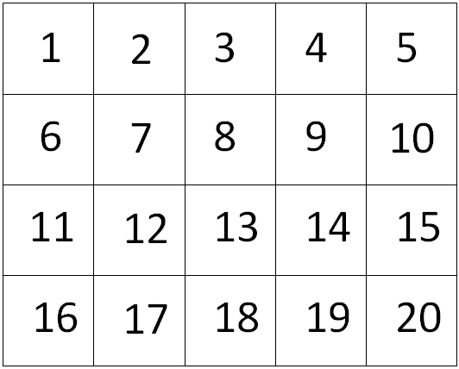

Model

5 4

1.0 1.0 1.0 1.0 1.0

1.0 1.0 0.2 0.2 1.0

1.0 1.0 0.2 0.2 1.0

1.0 1.0 1.0 1.0 1.0

(4 4)! only needed if used as a separate file

1.0 0.2 1.0 1.0

1.0 0.2 1.0 1.0

1.0 0.2 1.0 1.0

1.0 0.2 1.0 1.0

(5 3)! only needed if used as a separate file

1.0 0.2 1.0 1.0 1.0

1.0 0.2 1.0 1.0 1.0

1.0 0.2 1.0 1.0 1.0

## active.dat

This file contains the information about active and inactive cells. In DCIP2D V5.0 there is a capability of fixing the properties of particular cells with or without ability to influence the neighbouring cells. The structure of the active.dat file has to be consistent with the mesh and with model used for the inversion.

Below is an example of active.dat file. The header format indicates first the number of cells in the X direction, followed by the number of cells in Z direction. By default all cells are active. When “active.dat” file is introduced, all active cells are assigned a value of 1 and all inactive cells are assigned a value of “0” (no influence on neighbouring cells) or “-1” (allows influence on neighbouring cells.

14 7

1 1 1 1 1 1 1 1 1 1 1 1 1 1

1 1 1 1 1 1 1 1 1 1 1 1 1 1

1 1 1 1 0 0 0 0 0 1 1 1 1 1

1 1 1 1 0 0 0 0 0 1 1 1 1 1

1 1 1 1 0 0 0 0 0 1 1 1 1 1

1 1 1 1 1 1 1 1 1 1 1 1 1 1

1 1 1 1 1 1 1 1 1 1 1 1 1 1





where dobs is the observed data and dpred  is the predicted data. The misfit d in equation (20) is the usual L2 norm of the difference between the observed and predicted data. This is appropriate when the data errors are independent and Gaussian with zero mean and standard deviation . In reality however some data might have very large errors. These are “outliers” and if an incorrect uncertainty is supplied, the weighted difference will be very large and this datum will contribute disproportionately compared to other data. This arises because of the squaring operation in equation (20). In order to handle situations where there are outliers, a more robust norm such as a Huber norm can be implemented (See Appendix 2 for details) can be implemented. The Huber norm is calculated according to equation (21). It has a user-specified coefficient “c and acts like a hybrid between L1 and L2 norms. Essentially normalized misfits with a value less than c are evaluated using L2 and those above are evaluated using L1.

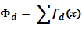

where **x = Wd(dobs-dpred)** and

**(21)**

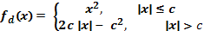

## 

## Selection of model objective function

The *model objective function* is specified in equation (11) and is a critical component of the inversion procedure. It is an important conduit for incorporating geologic information. It controls the “type” of model that will be generated and also geologic detail. The inversion algorithm will find a model that minimizes this function *subject to the constraint that the chosen model can generate predicted data that satisfy the misfit criteria*. The model objective function can be subdivided into two parts (as shown in figure 9).

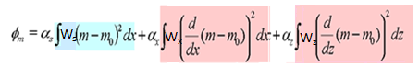

Figure 9. Components of the model objective function: blue – smallness, pink – smoothness.

1. The algorithm will try to find a model that is as close as possible to a reference model defined either as a halfspace (by default a halfspace with a resistivity equal to a weighted average of measured apparent resistivities), or as some other, more complicated model defined by the user (if there is enough prior knowledge).
2. The model will be as smooth as possible in the X and Z directions. The reference model can be left in or omitted in the derivative terms.

The significance of each component is controlled using the "Alpha" coefficients s, x, and z in the equation above. Therefore the user can request a model that emphasizes either component 1 (smallness) or component 2 (smoothness). The weighting functions ws, wx and wz can be incorporated to enforce more detailed information about the structure. Default values of these coefficients are determined by the program based upon the length scales of the survey and mesh.

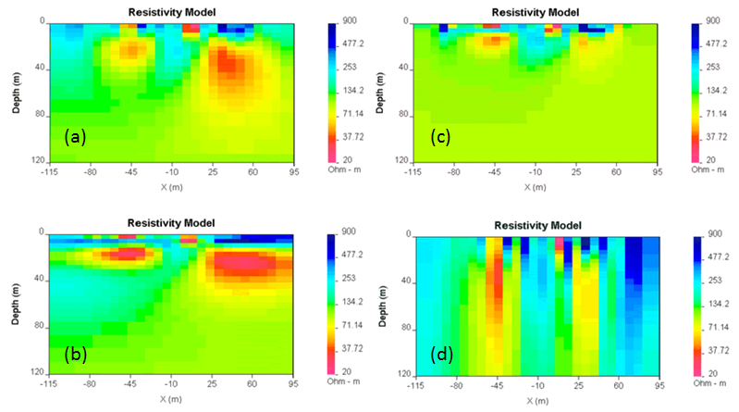

Figure 10. Effects of different values of s, x, z. (a):(0.01,1,1); (b): (0.01,1,0.01) ; (c): (1,0.01,0.01); (d): (0.01,0.01,1). All models produce the same data.

Figure 10 illustrates the effect of changing smallness and smoothness parameters on the inversion results. For the program DCIP2D V5.0, the default specifications for these "alpha" parameters have been found to work well as a first attempt, but experimentation and adjustment of the parameters defining the desired model type may be needed upon assessing the inversion results.

In addition to the smallness and smoothness coefficients, the new version of DCIP2D offers additional degrees of freedom to edit the model objective function. It is now possible to define the reference model in arbitrary form, as specified in equation (22).

**(22)**



The parameter “p” which takes values 1p2 controls the character of the model. If p=1 then the recovered model will tend to be “blocky” while if p=2 we obtain our usual L2 smooth model. Again, the reference model can be included, or not, in these terms. Examples of using this new objective function are shown in the “examples” section of the manual and additional detail about the numerical implementation is provided in Appendix 2.



Bounds constraints can be imposed on the model using the projected gradient method (Calamai, 1987). Each cell can be provided with an upper and lower bound (mL and mU), such that mLimi mUi



Using bounds can be helpful in imposing additional constraints if the properties of the model are known or just for enforcing the positivity condition.

## Evaluation of the results

The following steps should be taken on order to properly assess the results of an inversion:

* + 1. Check the dcinv2d.log (or ipinv2d.log) file. This file contains all the information about the input parameters and the inversion progress. Here are some key concepts of checking the log file:
* Did the inversion end with convergence?
* Have all the correct files been incorporated and inversion parameters properly set?
* Was the target misfit achieved?
* How many iterations were performed?
  + 1. Predicted data should be compared to the observations using the DCIP2D-DataViewer GUI. The observed data and the predicted data should look nearly identical. To see variations between them, click the "diff" button in the data viewing window. This changes the second pseudo-section to a "misfit map," which shows the differences between the two data sets (figure 11). The normalized misfit map (normalized by the assigned standard deviation) should look random, with maximum values of some small percentage of the measured data (based upon noise specifications).
    2. The resulting model should be checked using the DCIP2D_Model_Viewer GUI (provided with DCIP2D V5.0) Select "Padding cells" in the "Options"menu in this GUI to specify how many padding cells to drop from the display. You can also adjust the minimum / maximum values for the colour scale - necessary for comparing various models (see GUI usage manual for details).
    3. Theprogress of the inversion (or the convergence curve) during its iterations should also be checked (figure 12). In the model viewing window, the algorithm's progress can be displayed graphically by selecting the "Curves" toolbar button in the "View" menu. The resulting graph shows how the values of misfit and model norm varied at each iteration. ("Model norm" is the value of the *model objective function* - this is what we are trying to "minimize". The algorithm is programmed to add structure gradually in order to find a model that explains the data - i.e. it works on *reducing* the misfit value (**blue** curve) until the target misfit is reached. Then it must try to minimize the model norm without changing misfit. Thus, you should see a slight drop in the model norm value (**red** curve) until no more adjustments can be made to improve the situation.
    4. Is the model geologically reasonable? It is important to decide whether the resulting model is geologically reasonable. This final consideration is more subjective. A simple example is shown here, in figure 13 in which data produced by calculating data over the "true" 2D model (figure 13a) are inverted twice to produce two inversion results which are both inadequate. Figure 13b shows the model, which is "underfit" (a model recovered when the target misfit was too large). The program has stopped looking for details when predictions look only somewhat like observations. The image in figure 13c show an "overfit" model (a model recovered when the program has tried too hard to find details that explain every nuance in the observation and resulted in adding structure, which does not exist). In both cases the CHIFACT should be reviewed. In the “underfit” case it should be made smaller, in “overfit” case, bigger.

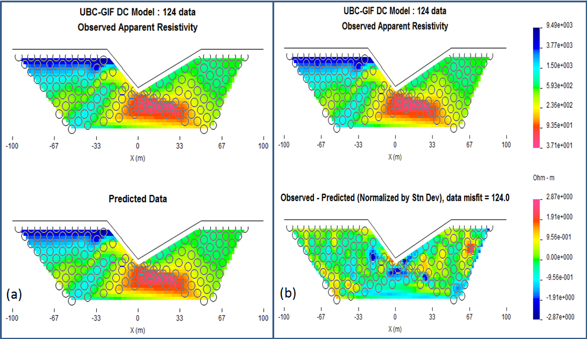

Figure 11. (a): Comparison of predicted data with the observed data. (b): viewing the difference between the predicted data and observed data, normalized by standard deviation.

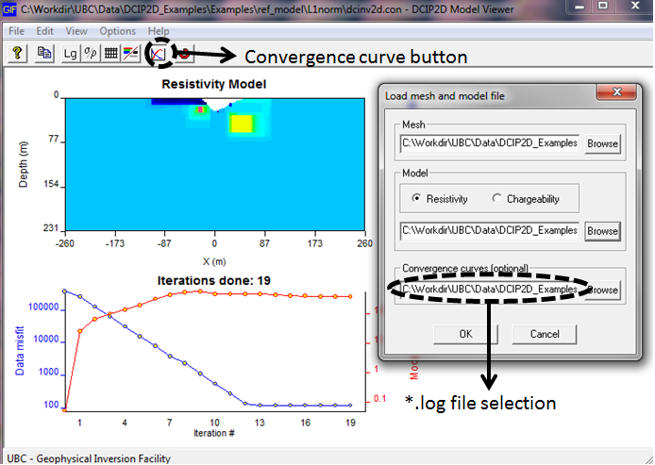

Figure 12. Viewing the model and the inversion progress.

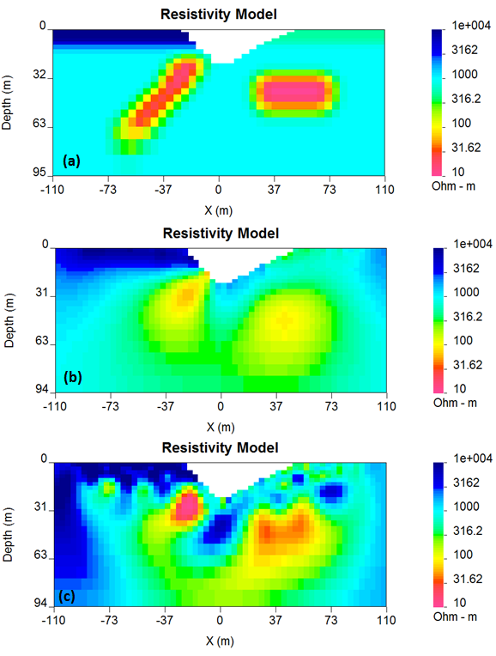

Figure 13. The effects of underfitting and overfitting the data. (a): True model; (b): Underfit recovered model; (c): Overfit recovered model

Another important concept to keep in mind during the verification of the inversion results is the depth of investigation concept. Some of the structure observed in the final model is strongly controlled by the data but other structure is controlled by the details of the regularization functional. By performing two inversions with different reference models or by computing the sensitivities it is possible to obtain some insight regarding which areas of the model are not controlled by the data. These should be removed (or blurred out) from the image before final presentation.

An example of this concept is shown in figure 14. The models in (a) and (b) were respectively recovered from inversions using reference models of a1000 ohm-m and a 106 **??** ohm-m (given by a default inversion). The DOI analysis was carried out and a threshold value of 0.5was used to omit parts of the model domain on the model recovered from a 1000 ohm-m background. See figure 14 (c).

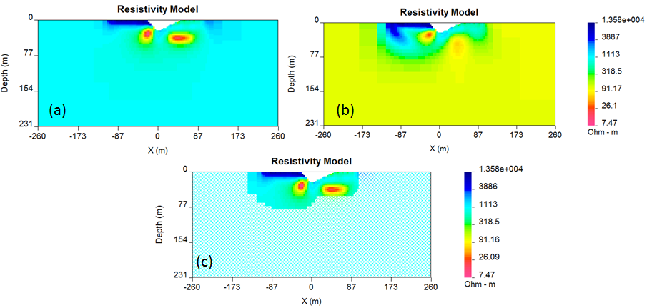

Figure 14. (a): The model recovered using a 1000 ohm-m background (b): model recovered from using a background of 106 ohm-m; (c): the model in (a) truncated to the depth of investigation using a cutoff value 0.5.

**DCIP2D manual:**

***Executing Programs***



**Content:**  Introduction |DCIPF2D | DCINV2D | IPINV2D |

## 

## Introduction

All programs in the package can be run by typing the program name followed by command line arguments. With such a format, they can be executed directly on the command line or in a shell script. When a program is executed without any arguments, it will print a simple message describing the usage. The command format and the control file format are described below.

#### Command format:

PROGRAM arg_1 arg_2 arg_3 ...

PROGRAM

Name of the executable program. If the program is not in the current directory, its path must be included also.

ARG n

A command line argument which is the name of a file. It is usually one of those described in the preceding section or a control file containing input parameters.

#### Control file format:

PARAMETER_1 !COMMENT

:

PARAMETER_n !COMMENT

FILE_NAME_1 !COMMENT

:

FILE_NAME_n !COMMENT

PARAMETER n

A constant number which is passed to the program. If more than one parameter is required on the same line, they must be separated by a space.

FILE_NAME n

Name of a file to be passed to the program. There is always only one file name per line.

COMMENT n

Optional comments which describe the parameter(s) on the same line. All comments must be the last fields of each line and be preceded by "!".

## DCIPF2D

This program performs forward 2D DC and IP modelling. As command line arguments, it requires fdmesh.dat, potgrid.dat, and model.con for DC forward modelling. As alternative to model.con the argument model.chg is required for IP modelling. An optional argument topo.dat is required when surface topography is present. The program produces a potential data file named “obs.dat”, and an apparent chargeability data file named “obs_ip.dat” when IP forward modelling is requested. The names of input files are specified by users but the names of output files are fixed. When topo.dat is supplied, it is used by DCIPF2D to define the topographic surface of the model and the forward modelled apparent conductivities and chargeabilities simulate the data acquired on the topography; otherwise, the program assumes a flat earth's surface at *z* = 0 and carries out the modelling accordingly.

#### Command line usage:

dcipf2d dcipf2d.inp

#### Format of the control file dcipf2d.inp:

The following is a list of valid tags that can appear in the dcipf2d.inp file. The tags should be in all UPPERCASE followed by extra information such as filenames or values. The tags can appear in any order in the input file. Each new tag has to start from the new line. If the supplied filename contains spaces, then the full filename typed in the command line should be in "quotes". In the input file, everything after the ! will be treated as a comment and ignored.

FWD DC - only forward model conductivities to calculate DC data.

Chargeability file is not needed.

FWD IP - forward model chargeabilities to calculate IP data.

FWD IPL - forward model chargeabilities to calculate IP data. This is accomplished

by multiplying chargeabilities by the sensitivity matrix.

For both the IP and IPL options, the DC data is also calculated.

FWD DC | FWD IP | FWD IPL

MESH FILE filename

LOC LOC_X filename | LOC LOC_XZ filename

TOPO DEFAULT | TOPO FILE filename

COND FILE filename | COND VALUE m

CHG FILE filename | CHG VALUE m

WAVE min max n

FWD DC filename

Only forward model conductivities to calculate DC data, chargeability file is not needed

FWD IP filename

Forward model chargeabilities to calculate IP data, DC data will be also calculated

FWD IPL filename

Forward model chargeabilities to calculate IP data. This is accomplished by multiplying chargeabilities by the sensitivity matrix (see equation (9) for details)

MESH FILE filename

A mesh file is supplied

LOC LOC_X filename

File contains only X locations

LOC LOC_XZ filename

File contains X and Z locations

TOPO DEFAULT

No topography

TOPO FILE filename

Topography is stored in a file

COND FILE filename

File containing electrical conductivities for forward modeling for the given mesh

COND VALUE

Fixed uniform halfspace electrical conductivity value for forward modeling

CHG FILE filename

File containing chargeabilities for forward modeling for the given mesh

CHG VALUE

Fixed uniform halfspace chargeability value for forward modeling

WAVE wave_min wave_max

Wave values to use. There will be n wave values, log spaced from wave_min to wave_max. The default is WAVE 2.5e-4 1.0 13**.**

#### Input files:

*dc/ip*

Enter dc to perform only dc forward modeling or enter ip to perform both DC and IP modeling

*fdmesh.dat*

Finite difference mesh

*potgrid.dat*

Electrode locations

*model.con*

Cell values of a conductivity model

*model.chg*

Cell values of a chargeability model

*topo.dat*

Surface topography (optional)

#### Output files:

*obs.dat*

The DC potential data

*Obs_ip.dat*

The apparent chargeability datDCINV2D

DCINV2D performs the inversion of the DC resistivity data in file obs.dat. The program requires a control file as the argument on the command line. The control file contains the control parameters and the names of input files. As input, the program requires the mesh file, potential data file, initial and reference models, the optional topography and special weighting files. It outputs the inverted model to a file named **dcinv2d.con**.

To assist the user's initial inversion of field data with minimal amount of input of parameters, the current version of the program has a set of built-in default options. These include:

1. default assignment of error standard deviation,
2. default mesh,
3. default reference model.

Using these defaults, a user need only supply the observed data and surface topography data to perform an inversion. Depending upon the outcome of this inversion, one may then proceed to a refined inversion by exerting more control through the input parameters.

#### Command line usage:

dcinv2d dcinv2d.inp

#### Format of the control file dcinv2d.inp:

The following is a list of valid tags that can appear in the dcinv2d.inp file. The tags should be in all UPPERCASE followed by extra information such as filenames or values. The tags can appear in any order in the input file. Each new tag has to start from the new line. The design otherwise is similar to that of dcipf2d.inp.

MESH DEFAULT | MESH FILE filename | MESH NC_ASPR n a

OBS LOC_X filename | OBS LOC_XZ filename

NITER n

CHIFACT DEFAULT | CHIFACT c

INIT_MOD [DEFAULT | FILE filename | VALUE m]

REF_MOD [DEFAULT | FILE filename | VALUE m]

ALPHA [DEFAULT | FILE filename | VALUE a_s a_x a_z | LENGTH Lx Lz]

WEIGHT [DEFAULT | filename | FILES filename_s filename_x filename_z]

WAVE min max n

STORE_ALL_MODELS TRUE | STORE_ALL_MODELS FALSE

HUBER NONE | HUBER c

EKBLOM rho_s rho_x rho_z eps_s eps_x eps_z

INVMODE SVD | INVMODE CG

CG_PARAM maxit tol

ACTIVE_CELLS filename

USE_MREF TRUE | USE_MREF FALSE

BOUNDS NONE | BOUNDS VALUE value_lower value_upper

BOUNDS FILE_L file_lower

BOUNDS FILE_U file_upper

#### Control parameters in the input file: (* indicate the default settings)

MESH

2D mesh. The mesh file is required if any of the models are supplied (initial, reference, weight, bounds, active cells).

MESH DEFAULT

A mesh file "dcinv2d.msh" will be created which has 3 cells between electrodes and the aspect ratio of the top cells set to 3.

MESH FILE filename

A mesh file. Is supplied.

MESH NC_ASPR n a

A mesh file."dcinv2d.msh" will be created which has /n/ cells between electrodes and the aspect ratio of the top cells set to /a/.

#### OBS filename

#### File containing electrode locations, observations, and optionally standard deviations. This file is required.

#### OBS LOC_X filename

#### File contains only X locations (surface).

#### OBS LOC_XZ filename

#### File contains X,Z locations.

#### NITER n

#### Maximum number of iterations to perform. If this line is missing, the default is 100.

#### CHIFACT

#### Chifact. The inversion will stop when data misfit ~= chifact * number of data .

#### CHIFACT c*

#### A value of /c/ will be used. If this line is missing, then the value will be 1.

#### CHIFACT DEFAULT

#### Initially, a very small value (1.e-3) will be used. When the misfit stops decreasing chifact will be changed by 10%.

#### TOPO DEFAULT*

#### No topography

#### TOPO FILE filename

#### Topography is stored in a file.

#### INIT_MOD

#### Initial conductivity model.

#### INIT_MOD DEFAULT*

#### Initial model is equal to the reference model.

#### INIT_MOD FILE filename

#### Initial model is in a file.

#### INIT_MOD VALUE m

#### Initial model is a constant value.

#### REF_MOD

#### Reference conductivity model.

#### REF_MOD DEFAULT

#### Reference model is equal to the best fitting halfspace.

#### REF_MOD FILEfilename

#### Reference model is in a file.

#### REF_MOD VALUE m*

#### Reference model is a constant value.

#### ALPHA

#### Tag line for alpha values used in W'W . Options following this tag are:

#### DEFAULT*

#### 1.e-3 *\** (90/max electrode separation)2, a_x = a_z = 1.

#### FILE filename

#### Dipping and alpha values are in a file

#### VALUE a_s a_x a_z

#### Use thesupplied alpha values*.*

#### LENGTH L_x L_z

#### Use thesupplied length scales values*.*

#### *Example: ALPHA LENGTH 200 200*

#### WEIGHT

#### Weights for W'W matrix.

#### WEIGHTDEFAULT*

#### No weighting is supplied.

#### WEIGHT filename

#### Weighting is in a file. For Ws there will be a weight value for each cell. If nx is the number of cells in the x and and nz is the number in the z direction then the number of weights in WX is (nx-1)*nz and the number of weights in WZ is (nz-1)*nx.

#### WEIGHTFILES filename_s filename_x filename_z

#### Weighting matrixes are included separatelly for the smallest model and for the smooth model in each direction. Each weighting file must be suppluied with its own header equal to the number of elements in the matrix.

#### WAVE wave_min wave_max n

#### Wave numbers used in the cosine transform. There will be n wave numbers, logarithmically spaced from wave_min to wave_max. The default is:

#### WAVE 2.5e-4 1.0 13

#### STORE_ALL_MODELS TRUE

#### A model and predicted data are stored for each iteration.

#### STORE_ALL_MODELS FALSE*

#### Only the final model and predicted data are stored.

#### INVMODE SVD*

#### The system is. solved using a subspace method with basis vectors. This is the solution methodology for the original code.

#### INVMODE CG*

#### The system is solved using Conjugate Gradient method. This is a new implementation and allows for additional constraints to be incorporated.

#### CG_PARAM maxit tol

#### Maximum number of iterations and tolerance for the CG solver.The default is: CG_PARAM 10 1.e-2

#### HUBER c

#### Huber norm is used in evaluating the data misfit. This option is available only through the CG solution. Default settings are: HUBER 1e+100.

#### EKBLOM rho_s rho_x rho_z eps_s eps_x eps_z

#### Ekblom norm is used on the model objective function. This option is available only through the CG solution. The default parameters are: EKBLOM 2. 2. 2. 0. 0. 0.

#### ACTIVE_CELLSfilename

#### The file is stored in the same format as the model files. The cell values could be 1 (cell is active); 0: (cell is inactive); -1: ( cell is inactive, but it can influence active cells near it. If this option is missing, then all cells below topography are active).

#### USE_MREF TRUE*

#### Reference model is in the X and Z derivative terms.

#### USE_MREF FALSE

#### Reference model is incorporated only in the smallest model component. It is not in the X and Z derivative terms*.* If the active cell file contains any cells equal to -1, then only USE_MREF FALSEcan be used.

#### BOUNDS NONE

#### No bounds

#### BOUNDS FILE_L file_lower

#### File containing lower bound.

#### BOUNDS FILE_U file_upper

#### File containing upper bound.

#### BOUNDS VALUE value_lower value_upper*

#### Constant lower and upper bound. Default values: value_lower = 0; value_upper = 1000

#### Output files:

dcinv2d.con

Conductivity model of the latest iteration. The model is stored in the [model.con](#_Model.con(chg)) format. This file is overwritten at the end of each iteration.

dcinv2d.out

Convergence information of past iterations. This file lists the values of data misfit, the model objective function, and the ridge regression parameter as functions of iteration.

dcinv2d.log

Log file containing the detailed information about each iteration.

dcinv2d.pre

Predicted potential data from the inverted model in the latest iteration. The predicted data is in the format of obs.dat with the field corresponding to data error omitted. This file is overwritten at the end of each iteration.

dcinv2d.msh

Default mesh used in the inversion. The default mesh is in the format of fdmesh.dat. This file is output for use in the subsequent IP inversion.

#### Examples of DCINV2D Control File:

The following is an example control file. In this file the provided references are describing an inversion to be performed on data from a file obs_dc.dat for a surface array configuration (OBS LOC_X) with topography described in the file topo.dat. The smallness coefficient is user-defined (ALPHA VALUE) and is set to 10-3 . If alpha_x =1.0 then the length scale Lx is 31.6 meters. If alpha_z=1.0 then the length scale Lz is also 31.6 m in the z-direction. A CHIFACT of 1 is applied. The initial and reference model values (INIT_MOD) and (REF_MOD) are set to 1.0*10-3 S/m (or 1000 Ohm*m). Huber norm (HUBER) is defined in the control file, but the coefficient is set so high (1.e+10) that in reality Huber norm is not to be used for this inversion. Ekblom norm (EKBLOM) is set to default values (2. 2. 2. 1.e-04 1.e-04 1.e-04). The system is solved (INVMODE) using the Conjugate Gradient (CG) solver with user-defined parameters (800 iterations and 1.e-06 fit tolerance).

OBS LOC_X obs_dc.dat

TOPO FILE topo.dat

MESH FILE mesh.msh

ALPHA VALUE 1.e-3 1. 1.

CHIFACT 1.

INIT_MOD VALUE 1.e-03

REF_MOD VALUE 1.e-3

HUBER 1.e+10

EKBLOM 2. 2. 2. 1.e-04 1.e-04 1.e-04

INVMODE CG

CG_PARAM 800 1.e-6

To use maximum default values only the observation file and the inversion mode (INVMODE) are needed to be specified.

**NOTE-1**: To have the program display a sample input file (all possible parameters), type: dcinv2d -inp

**NOTE-2**: If a special weighting (w.dat) is supplied by the user, care should be taken so that the final weighting matrix constructed by the program is positive definite. This property can be destroyed when the combination of the cell weighting coefficients and component coefficients (s, x, z, see the description of special weighting w.dat file) makes the diagonal elements too small. Under such circumstances, the program will usually print in the log file the indices of the rows which are not diagonally dominant. In the most severe situation, the program will output an error message indicating that the matrix may not be positive definite. When these messages appear, the user should stop the program execution and redesign the special weighting by increasing the value of *s* or decreasing the dynamic range of *WS* .

**NOTE-3:** DCINV2D will terminate before the specified maximum number of iterations is reached if the expected data misfit is achieved and if the model norm has plateaued. However, if the program exits when the maximum iteration is reached, the file dcinv2d.out should be checked to see if the desired (usually equal to the number of data) has been reached and if the model norm is no longer changing. If either of these conditions has not been met then the program should be restarted. If the desired misfit level is not achieved, but the model norm has plateaued and the model is not changing between successive iterations, then the user may want to adjust the target misfit to a higher value. Also an investigation as to which data are most poorly fit can be informative. It may be that the assigned standard deviations to specific data are unrealistically small. The program restarts using the information in dcinv2d.out and dcinv2d.con.

**NOTE-4:** The default mesh in DCINV2D is generated assuming that the data are collected by commonly used arrays and that the topographic relief is moderate. Thus the default mesh may not be optimal when the data are collected with unusual electrode geometry or when data are collected over severe surface topography. In such cases, the user should redesign the mesh so that it is better suited for the particular needs of the data set.

**NOTE-5:** We stress that the default errors are only an initial guess and they facilitate a preliminary inversion of the data. The user will want to alter these error estimates for the final inversion used for interpretation. The data with the default errors are written in the file dcinv2d.log using the format of obs.dat. They can be copied to a file for finer adjustment of the error estimates or the user can supply his or her own errors directly.

## IPINV2D

IPINV2D performs the inversion of the apparent chargeability data in file obs_ip.dat. The program requires a control file as the argument on the command line. The control file contains the control parameters and the names of input files. The program requires as input the mesh file, apparent chargeability data file, the conductivity model from DCINV2D, initial and reference models, and possibly a special weighting file. It outputs the inverted model in a file named ipinv2d.chg. The command format and the control file format are described below.

#### Command line usage:

ipinv2d ipinv2d.inp

#### Format of the control file ipinv2d.inp:

The format and the associated parameters are virtually the same as those used in the DCINV2D , however there is an option to specify a conductivity file acquired from the DC resistivity inversion.

COND FILE filename

The conductivity file, acquired from DC inversion (this must have the same mesh and the same topo files associated with it.

COND VALUE m

A halfspace conductivity value can be assigned.

#### Control parameters:

#### Output files:

ipinv2d.chg

Chargeability model of latest iteration. This file is overwritten at the end of each iteration.

ipinv2d.out

Value of the objective function and the value of the Tikhonov parameter as functions of iteration.

ipinv2d.log

Log file containing detailed information about each iteration.

ipinv2d.pre

Predicted apparent chargeability data from the inverted model in the latest iteration. The predicted data are in the format of obs_ip.dat with the field corresponding to the data error removed. This file is overwritten at the end of each iteration.

**NOTE-1**: To have the program display a sample input file, type: ipinv2d -inp

**NOTE-2**: If a special weighting (w.dat) is supplied by the user, care should be taken so that the final weighting matrix, *WmTWm* , constructed by the program is positive definite. This property can be destroyed when the combination of the cell weighting coefficients and component coefficients (ALPHAS, ALPHAX, ALPHAZ, see the description of special weighting w.dat) makes the smallest model component too small or even negative. Under such circumstances, the program will usually print in the log file the indices of the rows which are not diagonally dominant. In the most severe situation, the program will output an error message indicating that the matrix may not be positive definite. When these messages appear, the user should stop the program execution and redesign the special weighting.

**NOTE-3**: IPINV2D will terminate before the specified maximum number of iterations is reached if the expected data misfit is achieved and if the model norm has plateaued. However, if the program exits when the maximum number of iterations is reached, the file ipinv2d.out should be checked to see if the desired (usually equal to the number of data) has been reached and that the model norm has plateaued. If not, the inversion should be restarted. If the desired misfit level is not achieved, but the model norm has plateaued and the model is not changing between successive iterations, then the user may want to adjust the target misfit to a higher value. Also an investigation as to which data are most poorly fit can be informative. It may be that the assigned standard deviations to specific data are unrealistically small. The program restarts using the information in ipinv2d.out and ip2dinv.chg.

**NOTE-4**: We stress that the default errors are only an initial guess and they facilitate the preliminary inversion of the data. The user will want to alter these error estimates for the final inversion used for interpretation. The data with the estimated errors are written in the file ipinv2d.log using the format of obs.dat. They can be copied to a file for finer adjustment of the error estimates.

This is especially important with IPINV2D. The apparent chargeability pseudo-section is usually characterized by a fluctuating background of very low values that are dominated by noise. The estimated errors need to account for the variation in this background. Although our implementation of error estimation has been tested on available data sets and has yielded reasonable results, it can still underestimate the noise for an atypical set of data. If this occurs, the inversion could produce a model that has excessive structure when the observed data are overfit, or it could fail completely if the misfit is dominated by the contribution from data points in the background region. The former case can be diagnosed by observing excessively high amplitude of the recovered model, while the latter is indicated by an unreasonably large misfit. In these situations, the inversion must be rerun with increased error estimates.

**NOTE-5**: The default conductivity of a uniform halfspace for IP inversions should only be used for preliminary examination of the data. When there is little structure in the background conductivity, the inversion using this default mode can yield a reasonable chargeability model and it is justifiable to fit the data close to the expected misfit value. However, when the background conductivity deviates greatly from a uniform halfspace, reproducing the data to within the assumed errors will certainly result in overfitting the data. If the halfspace conductivity is assumed, then it is prudent to assign a value greater than 1.0 for *chifact* when the background conductivity is structurally complex. The judgement can be made based upon the complexity of the apparent resistivity pseudo-section.

## 

**DCIP2D manual:**



***Examples***

**Content:**  Synthetic model | DC Examples |IP Examples | Large data set example | Field data example |Borehole examples|

## Synthetic model

We use several synthetic examples to illustrate various aspects of DCIP2D Version 5.0. The emphasis of the test examples is to show the newly added features of the inversion programs. A synthetic conductivity model is shown in figure 15a and resultant synthetic data I shown in figure 15b.

The synthetic model consists of two conductors buried in a uniform halfspace, which is overlain by an overburden of variable conductivity. A V-shaped valley is cut out to simulate the surface topography. The background has a conductivity of 1 mS/m and the overburden has a conductivity of 0.1 mS/m on the left and 2 mS/m on the right. The buried conductor on the left has a dip of 135o and a conductivity of 100 mS/m, and it is buried at a depth of 20 m to the top. The conductor on the right is a horizontal and conductive block of 100 mS/m buried at a depth of 25 m. The forward modelling uses a mesh of 48 cells in the x-direction and 27 cells in the z-direction so there are 1296 cells. In the survey, surface electrodes are located every 10 m in the interval *x*=(-100,100) m. We have simulated pole-dipole data with a=10 m and n=1, 8. The data have been contaminated with independent Gaussian noise whose standard deviation is equal to 5% of each accurate datum.

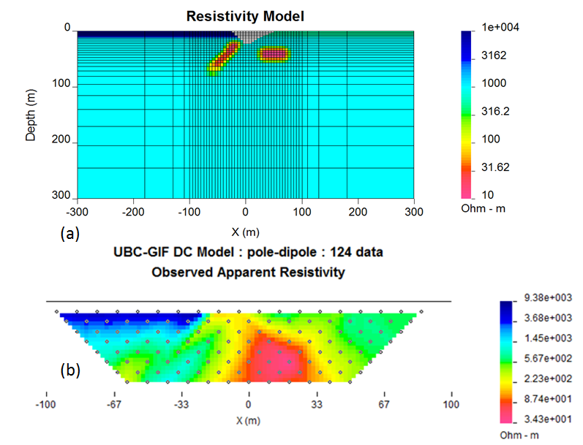

Figure 15. (a): The true synthetic resistivity model; (b): synthetic model.

## DC Examples

We have carried out nine DC inversions of the above DC data set. The examples were designed to illustrate the performance of the inversion program when different combinations of input parameters are used.

**Ex 1: DC Inversion: All default**

First, the synthetic data were inverted using the all-default option (see the control file configuration provided below:

OBS LOC_X obs_dc.dat

TOPO FILE topo.dat

MESH FILE dcinv2d.msh

In this file the first line (OBS LOC_X) indicates that the data file obs_dc.dat only includes surface locations; the second line (TOPO FILE) contains the reference to topography file topo.dat; the third line (MESH FILE) contains reference to the mesh file dcinv2d.msh. If there is no topography it is not necessary to include either the mesh, or the topography file in all-default mode. DCINV2D_V5.0 will construct a mesh in automatic mode and consider topography to be zero. In our case we have user-defined topography and mesh file is provided. The result of the all-default inversion is shown in figure 16. The best fitting halfspace was approximately 120 ohm-m.

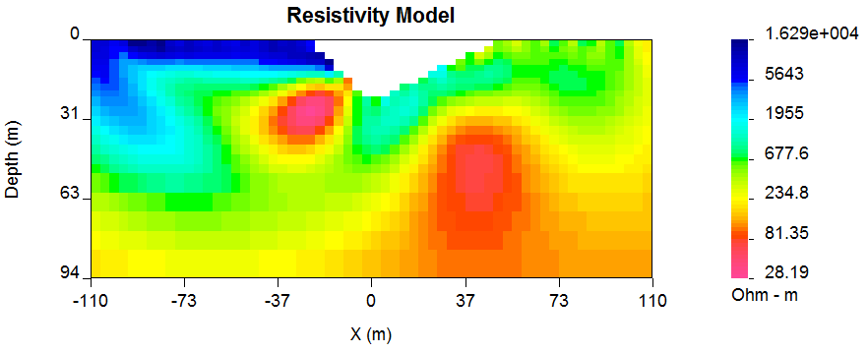

Figure 16. Inversion of synthetic DC data using all-default mode.

**EX 2: DC Inversion: CG solution using a constant reference model**

In the next example, definition of some parameters has been set to user-defined and changed. In real life this can be done if there is a higher level of certainty regarding some starting parameters (a-priori information). The control file for the next example is provided below:

OBS LOC_X obs_dc.dat

TOPO FILE topo.dat

MESH FILE dcinv2d.msh

ALPHA VALUE 1.e-3 1. 1.

INVMODE CG

REF_MOD VALUE 1.e-3

INIT_MOD VALUE 1.e-3

In this example the fourth line (ALPHA VALUE) indicates that the smallness coefficient (s) is now user-defined (set to 0.001). The fifth line (INVMODE CG) means that the system solver has been switched from default (Singular Value Decomposition or SVD solver) to the Conjugate Gradient solver (CG). Line 6 (REF_MOD VALUE) has been set to 0.001 S/m (or 1000 Ohm m). Line 7 (INIT_MOD VALUE) has been set to the same as reference model. The results of applying these control file parameters are shown in the inversion model in figure 17.

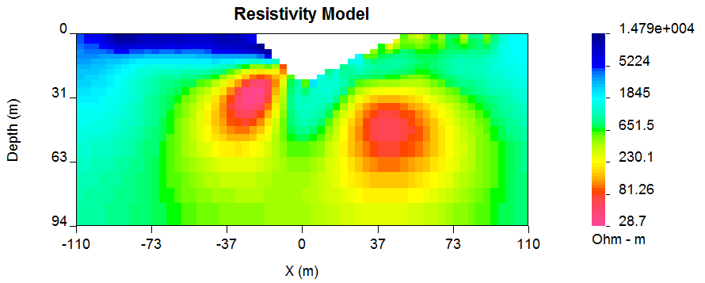

Figure 17. Inversion of synthetic DC data using user-defined smallness parameter (s) 1000 Ohm m halfspace as both: reference and a starting model.

The basic features of the models in figure 16 and figure 17 are similar. Both conductors have been located and so has the resistive overburden on the left. (Compare with the synthetic model in figure 15). Nevertheless, there are differences. Figure 17, which uses a more resistive reference model, supports the interpretation of closure for the body on the right. There is also an odd structure emanating from the left most part of the resistive overburden observed in figure 16 that is not observed in figure 17. The primary differences between the two models can be explained through the use of a DOI (Depth of Investigation) plot. For the present we use figure 17 as a reference and figure 16 as an additional model.

When the inversion volume is cut with respect to the DOI, then differences in the images are no longer so apparent. For the remainder of the example section we shall use the reference the model described in figure 17 (1000 Ohm m halfspace) as the “default” model.

**Depth of Investigation (DOI)**

Models produced by inversion of DC resistivity data tend to approach the background conductivity of the reference model. At those depths the recovered model is no longer being influenced by the data. We can use this result to help estimate our depth of investigation. If there are at two reasonable models obtained using different reference models, the two models can be compared to identify which regions of the model are most significantly affected by the measurements. The results of doing this are explained next.

|  |
| --- |
|  |

Using the DCIP2D_V5.0 program, the method is applied within the DCIP2D_Model_Viewer GUI, using "Depth of investigation" option in the "Options" menu. There must be a second model that was recovered using the same mesh as the one being observed. Any two different inversions results can be used. Here we use 1000 Ohm-m halfspace as our “best” model and we want blank out those sections of the model that are not well controlled by the data. A second inversion using a background of 106 Ohm-m (the default value from the code) and used that to compute the DOI. In figure 18(a-b) shows the model with cutoffs of 0.1 and 0.4.

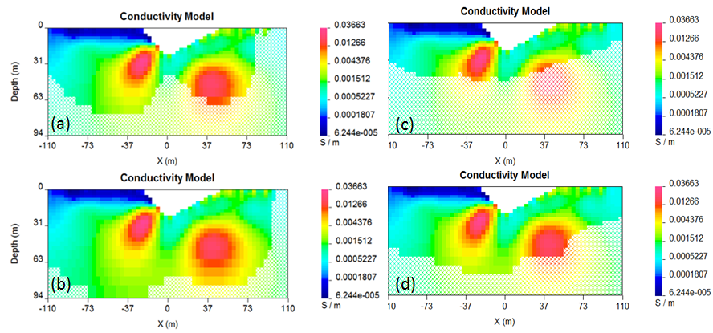

Figure 18. Assessing the depth of investigation (DOI): (a): based on recovered model (cut-off=0.1); (b): based on recovered model (cut-off = 0.4); (c): based on sensitivity (cut-off = 0.5); (d): based on sensitivity (cut-off = 0.6).

Another option to assess the depth of investigation is through the analysis of the sensitivities. In DCIP2D V5.0 there is a capability to visualize the sensitivities using the DCIP2D_Model_Viewer GUI (Figure 18c and Figure 18d). Generally, the lower sensitivities correspond to less reliable model parameters (deeper-seated cells); higher sensitivities correspond to those model cells, which have most effect on the data (usually closer to surface). A good way to assess the DOI is by plotting the model on the full mesh extent (including the padding cells, Figure 19). In this figure we use the DOI evaluated from 1000 and 106 Ohm-m halfspaces (that is, the same as Figure 18a and Figure 18b). As the DOI threshold decreases we limit the region of the model to that which is most controlled by the data. See (Figure 19a-c). The final choice of cutoff is selected by the user.

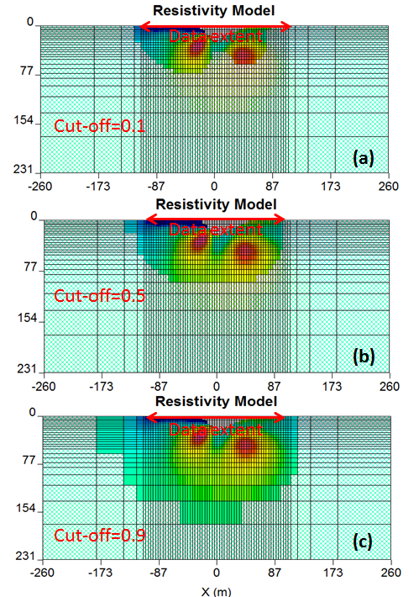

Figure 19. Depth of inverstigation plotted based on two models (a): cut-off = 0.1 (underestimated); (b) cut-off=0.5 (correctly estimated); (c): cut-off = 0.9 (overestimated)

**Introducing A-Priori geologic information**

**Ex 3: DC Inversion: Non-uniform reference model:**

The next example is very similar to the previous inversion, with an exception that a different reference model is introduced (figure 20). As opposed to the previous example, where the reference model was set to a 1000 Ohm m halfspace, the new model includes an elongated conductive (10 Ohm m) rectangular block. The elongated block has the same value as the conductivity anomaly but the boundaries do not coincide. Moreover the block in the true model has smoothed boundaries. In summary, the supplied reference model has captured some aspects of the true conductivity but it is not an exact reflection of what is there. This example has been contrived to illustrate what happens with the options of including, or omitting, the reference model in derivative terms in the objective function according to equations 1 and 2.

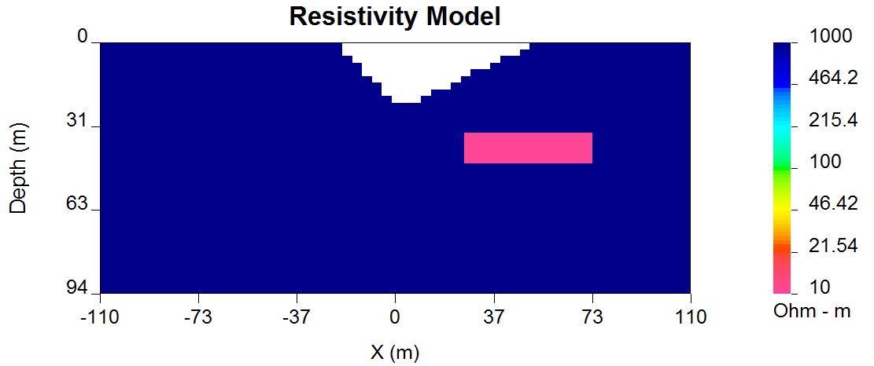

Figure 20. Reference model applied for the synthetic example illustration.

In the first example (control file provided below) the reference model was used in only the smallest model component.

OBS LOC_X obs_dc.dat

TOPO FILE topo.dat

MESH FILE dcinv2d.msh

ALPHA VALUE 1.e-02 1. 1.

REF_MOD FILE ref_new.con

INIT_MOD VALUE 1.e-03

USE_MREF FALSE

NITER 40

INVMODE CG

In this control file line 5 (REF_MOD FILE) now indicates that the reference model should be read from a file, rather than assigned a constant value; line 7 (USE_MREF FALSE) indicates that the reference model should be defined in non-derivative terms and line 8 (NITER 40) is indicating that the maximum number of iterations for this inversion should not exceed 40. The results of this inversion can be seen in figure 21.

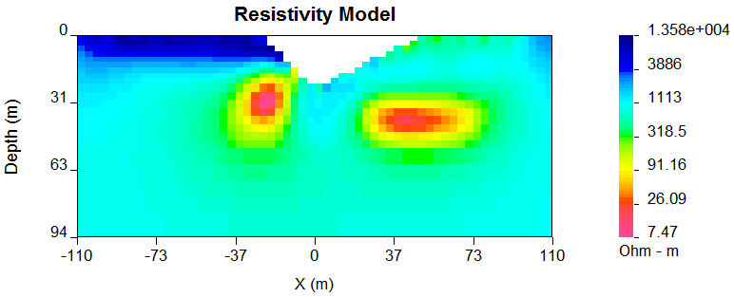

Figure 21. Inversion using the non-uniform reference model in the smallest model term.

This is a superior model compared to that in Figure 17. The magnitude of the conductive anomaly is much better recovered, although at 7.6 Ohm-m it is slightly less resistive than the true value of 10 Ohm-m. It has a well-defined elongated shape with steep gradational boundaries that are good representations of the true model.

If we are more confident in the locations of the boundaries of the block in the reference model then this can be incorporated into the inversion. We next carry out an inversion in which the reference model is included in the derivative terms. Below is the control file used for this inversion.

OBS LOC_X obs_dc.dat

TOPO FILE topo.dat

MESH FILE dcinv2d.msh

ALPHA VALUE 1.e-02 1. 1.

REF_MOD FILE ref_new.con

INIT_MOD VALUE 1.e-03

NITER 40

INVMODE CG

The line (USE_MREF FALSE) from the previous example has been eliminated, switching the inversion into the default mode (reference model is defined in the derivative terms in default mode). It could have been left in and changed to USE_MREF TRUE.

The result is shown in figure 22 and it produces a model that has boundaries at the same location as the reference block and there is even more over-shoot of the conductivity. For this example however, putting in the reference model into the derivative terms is stronger information than is justified. In most cases, the previous solution, where the reference model was left out of the derivative terms is preferable.

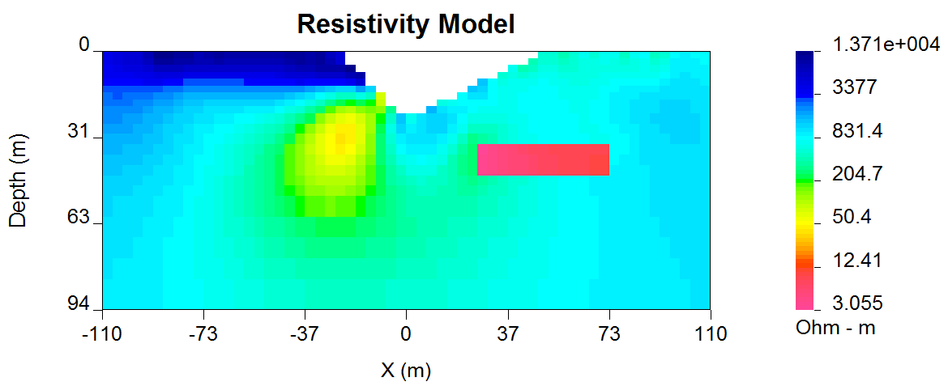

Figure 22. Inversion using the non-uniform reference model defined in derivative terms.

This is not always the case. Consider a situation where the goal is to find a body beneath an overburden layer. The model and the reference model are shown in Figure 23. It might be supposed that information about the overburden thickness and its resistivity have been obtained through drilling. Two inversions are carried out. In the first (Figure 24a) the reference model is omitted from the derivate term and the overburden boundary is characterized by a smooth transition. In the second case (Figure 24a) the reference model is included in the derivative terms and the result is a cleaner delineation of the overburden and better definition of the sought body.

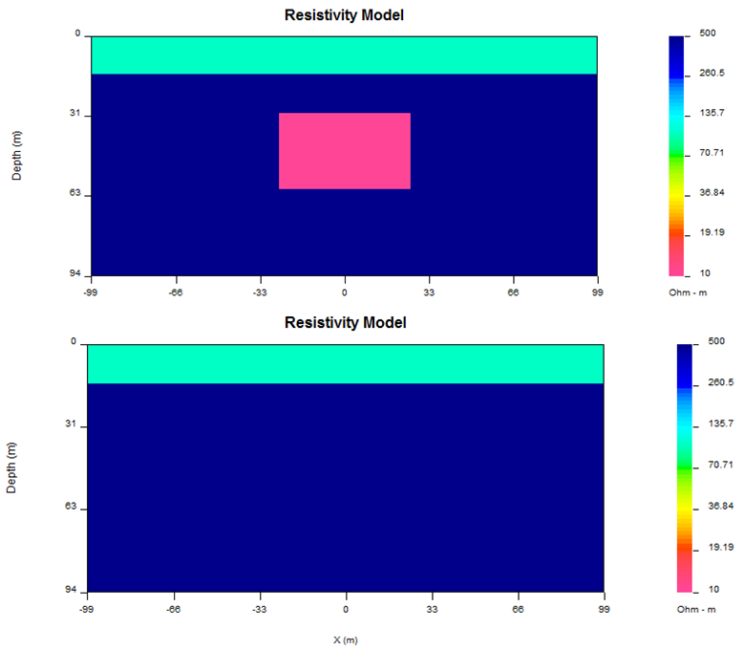

Figure 23. A conductive block underneath the overburden; (a): true model; (b) reference model.

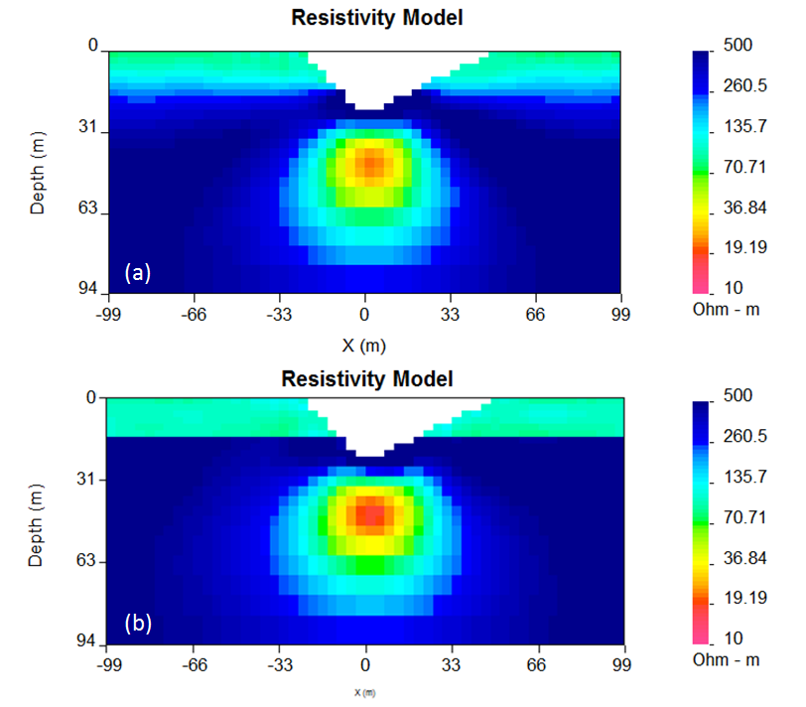

Figure 24. . Inversion results. (a): reference model is not included in the derivative terms ; (b): reference model defined in derivative terms.

**Ex 4: DC Inversion: Incorporating L1 norm for blocky model**

In the next example (figure 25) the geological information is incorporated in the model objective function using L1 normalization instead of the default L2 normalization. This approach is more computationally intensive; however it allows recovery of a blocky model and therefore is only justified if the blockyness is confirmed by a-priori data. The theoretical background behind the Huber and Ekblom normalization concepts can be found in Appendix 2 to this document. The control file for this example is provided below:

OBS LOC_X obs_dc.dat

TOPO FILE topo.dat

MESH FILE dcinv2d.msh

ALPHA VALUE 1.e-4 1. 1.

REF_MOD VALUE 1.e-3

INIT_MOD VALUE 1.e-3

EKBLOM 1. 1. 1. 1.E-1 1.E-1 1.E-1

INVMODE CG

In line 7 (EKBLOM 1. 1. 1. 1.E-1 1.E-1 1.E-1) the parameters of the Ekblom norm are defined (see appendix 2 for details). This Ekblom norm is the measure of the model objective function and is responsible for recovery of a blockier model.

The values of p for the Ekblom norm usually range from p=1 (L1 norm for blocky models) to p=2 (L2 norm for smooth models). Values of p between [1,2] yield transitional models and the user can experiment. The other input parameters needed for the Ekblom norms include the thresholding constants, **i.** We have not found a good default for these that is suitable for all problem and hence choice of the thresholds is left to the user’s discretion.

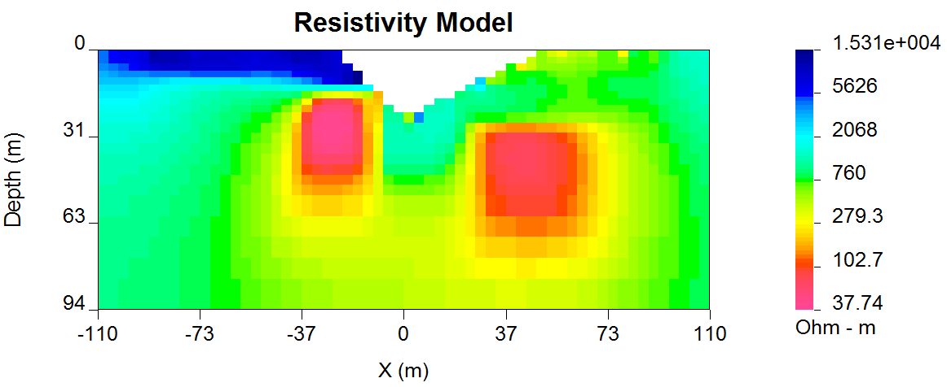

Figure 25. Using L1 measure (Ekblom norm) of model norm to recover a blocky model.

**Ex 5: DC Inversion: Incorporating inactive cells constraint**

In the next example it is illustrated how drilling data can be incorporated in the inversion using fixed cells constraint. In this example the reference model has been set to the same elongated conductive block model as shown in figure 20. The difference is that in this case additional information has been incorporated by fixing some reference model cell values. The values are taken from the reference model file (ref_new.con) but their values are fixed using active cells file (ACTIVE_CELLS active.txt), defined in line 6 of the control file (provided below).

OBS LOC_X obs_dc.dat

TOPO FILE topo.dat

MESH FILE dcinv2d.msh

ALPHA VALUE 1.e-3 1. 1.

REF_MOD FILE ref_new.con

ACTIVE_CELLS active.txt

INIT_MOD VALUE 1.e-3

INVMODE CG

The file format “active.txt” was previously discussed in the “Elements” section of the manual, however another example is provided below:

1 1 1 1 1 1 1 1 1 1 1 1 1 1

1 1 1 1 1 1 1 1 1 1 1 1 1 1

1 1 1 1 0 0 0 0 1 1 1 1 1 1

1 1 1 1 0 0 0 0 1 1 1 1 1 1

1 1 1 1 0 0 0 0 1 1 1 1 1 1

1 1 1 1 1 1 1 1 1 1 1 1 1 1

1 1 1 1 1 1 1 1 1 1 1 1 1 1

The format of this file is consistent with the model file, and the values equal to 1 define the model cells marked as “active”, while values equal to 0 define the model cells marked as “inactive” (without the capability affect the neighbouring cells).

The case when inactive cells do not influence their neighbours is shown in figure 26.

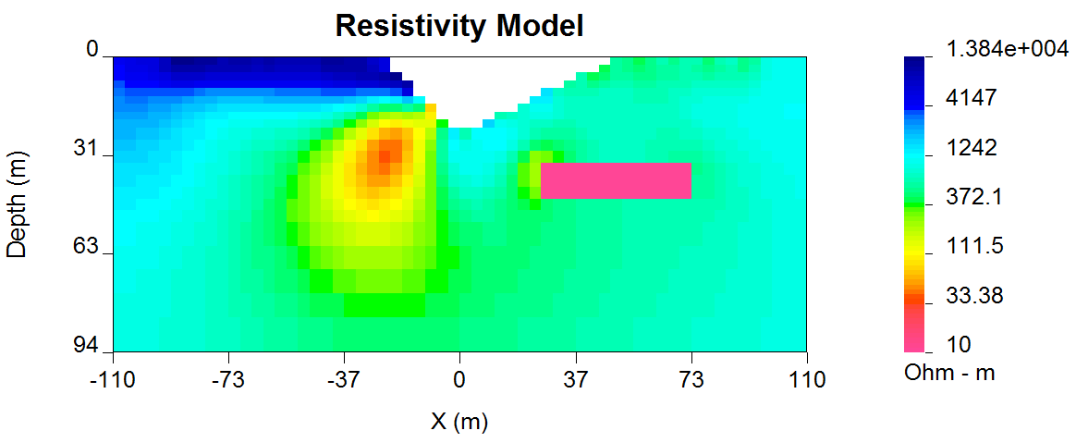

Figure 26. Reference model cells are inactive, and they do not influence the neighbouring cells.

If it is desired to have the inactive cells influence the values of neighboring cells then their values are set to -1 as in the file below. The resultant inversion model is shown in figure 27. The region of high conductivity has been extended away from the reference model and the anomaly smoothly transitions to the background.

1 1 1 1 1 1 1 1 1 1 1 1 1 1

1 1 1 1 1 1 1 1 1 1 1 1 1 1

1 1 1 1 -1 -1 -1 -1 1 1 1 1 1 1

1 1 1 1 -1 -1 -1 -1 1 1 1 1 1 1

1 1 1 1 -1 -1 -1 -1 1 1 1 1 1 1

1 1 1 1 1 1 1 1 1 1 1 1 1 1

1 1 1 1 1 1 1 1 1 1 1 1 1 1

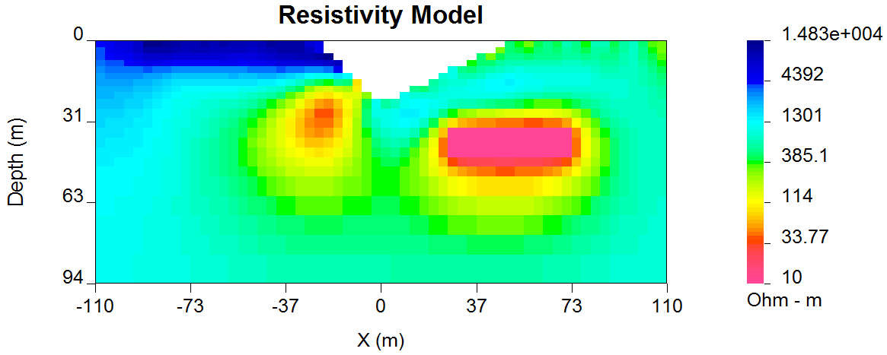Figure 27. Cells are inactive, but their values influence those of the neighbouring cells.

**Ex 6: DC Inversion: Using weighting functions**

The next example illustrates the situation when a-priori information is incorporated using the weighting function (W.dat file) The synthetic model for this example is the same as illustrated in Figure 23. Instead of reference model, a w.dat file was used. The control file used for this inversion is shown below. The reference to the W.dat file is provided in line 11 (WEIGHT W.DAT).

OBS LOC_X obs_dc.dat ! Data file

MESH FILE dcinv2d.msh

CHIFACT 1

NITER 50

TOPO FILE topo.dat

INIT_MOD VALUE 2.E-03

REF_MOD VALUE 2.E-03

ALPHA VALUE 1.e-03 1. 1.

INVMODE CG

USE_MREF FALSE

WEIGHT W.DAT

The recovered model is illustrated in Figure 28 and is very similar to the model shown in Figure 24b. The alternative of using W.dat file instead of the reference model facilitated the technical implementation of the a-priori constraints and brings an additional degree of freedom in being able to adjust the level of certainty in the a-priori information by editing the weighting coefficients. In our case the weighting coefficients were edited for the Wz matrix, where the sixth interface (corresponding to the bottom of the overburden) was set to 0.1 (as opposed to default weights of 1.0).

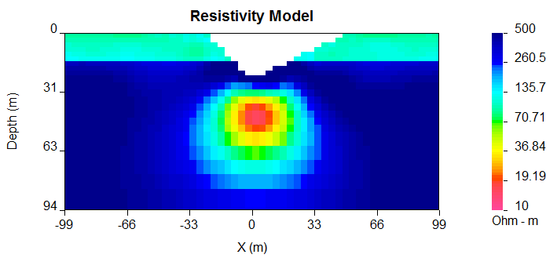

Figure 28. Inversion using weighting file (W.dat)

**Using Huber norm for data misfit**

**Ex 7. DC Inversion Using Huber norm for Data Misfit.**

The next example illustrates the effects that large data errors can have on the inversion and how these can be ameliorated with the Huber norm. The data are the same as used in previous examples except that 5 data have been severely perturbed. The inversions are carried out with the same STD estimates, as used previously, a 1000 ohm-m background, and a data file contaminated with bad apparent resistivity values. Figure 29 shows the contamination introduced to the apparent resistivity file used for the inversions.

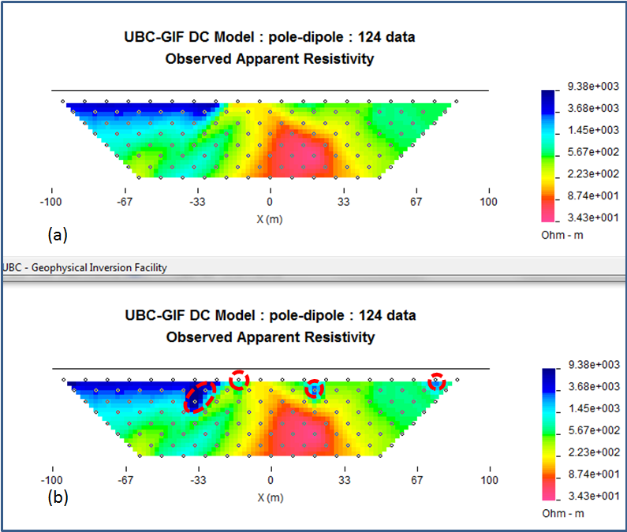

Figure 29. (a): Uncontaminated data; (b): contaminated data.

The contaminated data were inverted using a standard L2 normalization for the data misfit. The control file for this inversion is provided below:

OBS LOC_X obs_dc.dat

TOPO FILE topo.dat

MESH FILE dcinv2d.msh

ALPHA VALUE 1.e-3 1. 1.

REF_MOD VALUE 1.e-3

INIT_MOD VALUE 1.e-3

USE_MREF TRUE

INVMODE CG

NITER 20

CG_PARAM 20 1.e-2

The results of the inversion are shown in (Figure 30). The inversion ran for 20 iterations and the target misfit was not achieved and there were many artifacts. The reason is that the great effort was being made to fit the five erroneous data.

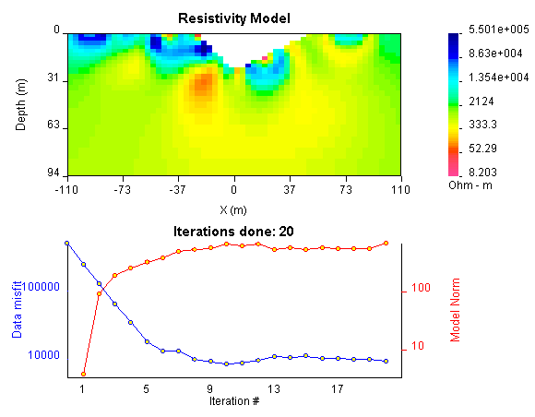

Figure 30. Inversion of contaminated data. L2 normalization of objective function and resultant conductivity model.

In Figure 31 we show the observed data and the normalized misfit. Three of the five outliers are distinct and they contribute a value of 2067.05to the final misfit of 9303. By recognizing them as outliers, they might be winnowed from further analysis but two erroneous data have been overfit by the modeling and as a result produced incorrect structure. This has led to other, higher quality data, having large misfits. This is characteristic of non-robust norms.

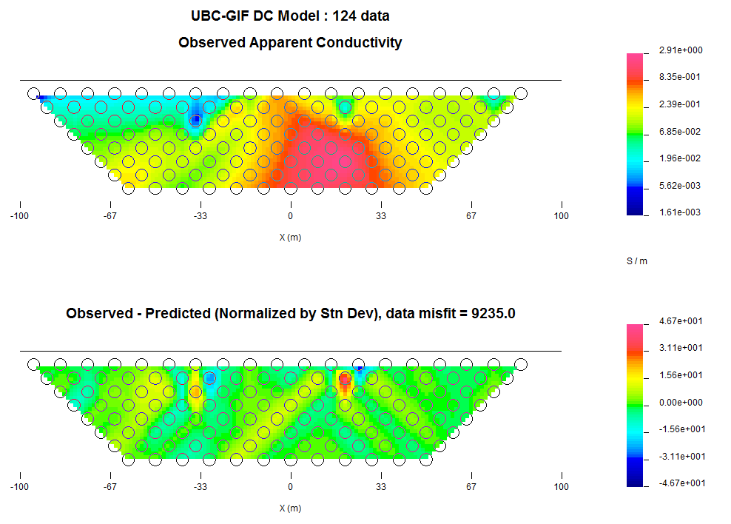

Figure 31. Observed data plotted against predicted for inversion using L2 normalization

In order to combat the effect that outliers in the data file may have on fitting the data using the L2 measure, Huber norm was imposed on the data fit (see appendix 2 for details). The example of the control file with Huber norm is shown below:

OBS LOC_X obs_dc.dat

TOPO FILE topo.dat

MESH FILE dcinv2d.msh

ALPHA VALUE 1.e-3 1. 1.

REF_MOD VALUE 1.e-3

INIT_MOD VALUE 1.e-3

HUBER 0.1

USE_MREF FALSE

NITER 40

INVMODE CG

Line 7 in this control file has been set to host (HUBER 0.1), which means that all normalized data misfits with value greater than 0.1 will be evaluated with the L1 measure. The results are shown in Figure 32 and they appear much better, than in previous case. Nevertheless, they can still be improved by recognizing the existence of the highly erroneous data and winnowing them from the inversion.

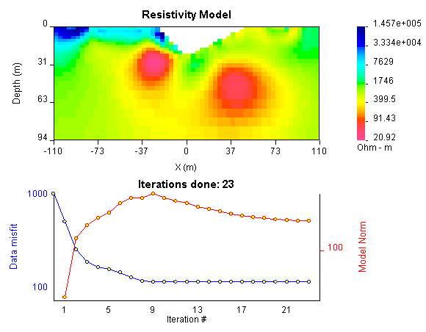

Figure 32. Inversion of contaminated data using Huber norm for the data misfit.

Although the recovery is far from perfect, the main conductor bodies are now shown with satisfactory detail, comparing to the L2 normalization.

## IP Examples

The inversion of IP data is almost identical to the inversion of DC resistivity data. The primary difference is that IP is a linear problem and the forward modeling matrix is the sensitivity matrix from the DC resistivity inversion. The IP inversion code has the same functionality as the DC resistivity code and the control lines are identical. One essential difference is that positivity is strictly enforced in the IP inversion. IP data can be negative but the intrinsic chargeability is always positive. There is no need to repeat all of the inversions done for the DC. Rather, we will invert only a few examples to illustrate the algorithm.

The synthetic model used for the IP inversions is shown in Figure 33a and resulting synthetic data, in Figure 33b. The model is very similar to that used in the DC example. It consists of two chargeable bodies (chargeability = 0.15), buried in a uniform halfspace of zero chargeability, which is overlain by an overburden of variable chargeability. A V-shaped valley is cut out to simulate the surface topography. The forward model of this setting was contaminated with 5% Gaussian noise.

The examples were designed to replicate the capabilities of DCIP2D_V.5.0, shown using the DC examples. The conductivity models used for IP inversions were mainly those, acquired from the corresponding DC inversions.

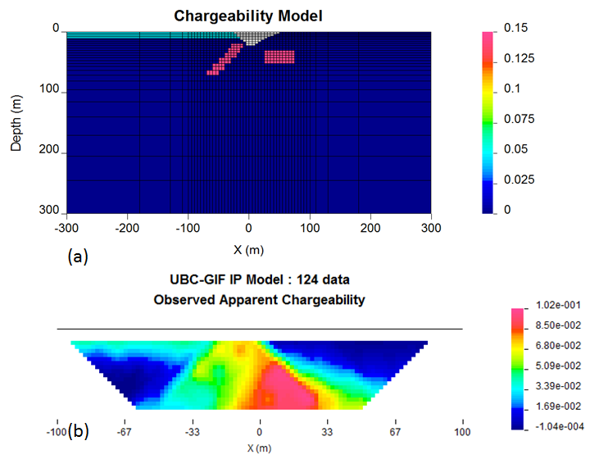

Figure 33. (a): The true synthetic chargeability model; (b): resultant data simulated using the forward modeling algorithm.

**Ex 1. IP Inversion: Zero-chargeability reference model.**

The first example was carried out using zero-chargeability reference halfspace and the conductivity model acquired from inverting the dc resistivity with 1000 Ohm m halfspace reference. The control file for this inversion is shown below:

OBS LOC_X obs_ip.dat

TOPO FILE topo.dat

MESH FILE dcinv2d.msh

COND FILE DCINV2D.CON

REF_MOD VALUE 1.e-05

INIT_MOD VALUE 1.e-05

ALPHA VALUE 1.E-03 1. 1.

INVMODE CG

In line 4 of this control file (COND FILE DCINV2D.CON) there is the reference to the resistivity (conductivity) file, an essential input parameter for an IP inversion. This file has to come from a corresponding DC inversion, carried out prior to the IP inversion. The results of this inversion are shown in figure 34.

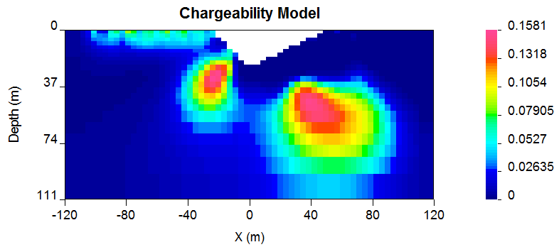

Figure 34. Chargeability model recovered for “zero” chargeability reference model and 1000 Ohm m conductivity.

**Introducing A-Priori geologic information**

**Ex 2. IP Inversion: Non-uniform reference model.**

In the next example, similarly to the DC inversions, we have introduced a chargeable block into the reference model (figure 35).

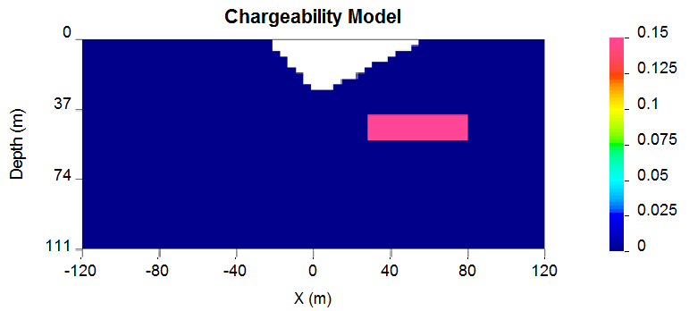

Figure 35. Reference model applied for the synthetic example illustration.

Further the new reference model was introduced in the inversion and omitted from the derivative terms. The control file for the inversion is virtually identical as in case with analogous inversion of the DC data, and is provided below. The resulting inversion is shown in figure 36.

OBS LOC_X obs_ip.dat

TOPO FILE topo.dat

MESH FILE DCINV2D.MSH

ALPHA VALUE 1.e-2 1. 1.

REF_MOD FILE ref_new.chg

INIT_MOD VALUE 1.e-05

USE_MREF FALSE

COND FILE DCINV2D.CON

INVMODE CG

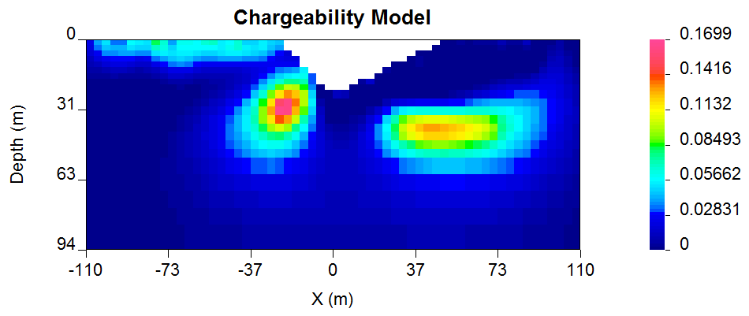

Figure 36. Inversion using the non-uniform reference model in regular terms.

**Ex 3. IP Inversion Using Ekblom measure to recover a blocky model**

In the next example the geological information is incorporated in the model objective function using L1 normalization instead of the default L2 normalization. This allows recovery of a blocky model. The control file for this example is provided below, and the resultant inversion model is shown in figure 37.

OBS LOC_X obs_ip.dat

TOPO FILE topo.dat

MESH FILE dcinv2d.msh

ALPHA VALUE 1.e-3 1. 0.1

REF_MOD VALUE 1.e-05

INIT_MOD VALUE 1.e-05

EKBLOM 1. 1. 1. 1.E-3 1.E-3 1.E-3

COND FILE DCINV2D.CON

INVMODE CG

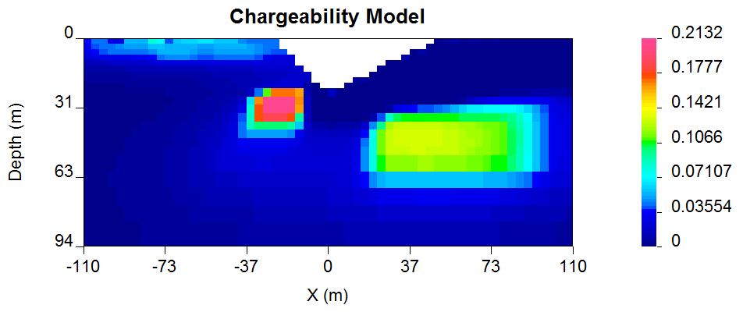

Figure 37. Using L1 measure (Ekblom norm) of model norm to recover a blocky model.

The resultant models are blocky and the central block has better defined boundaries than the deep block on the right. This arises because the right hand block is located close to the edge of the depth of investigation for the survey. To illustrate this we superpose the depth of investigation inferred by using the sensitivity function with a cutoff of 0.5. This is shown in figure 38. To illustrate the DOI the model has been plotted on a larger scale.

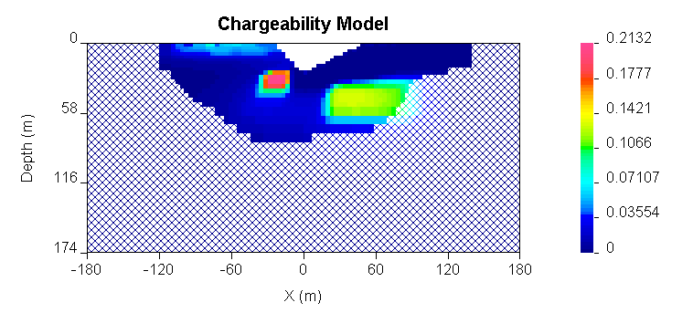

Figure 38. Depth of investigation, for the L1 data misfit IP inversion.

**Ex 4. IP Inversion: Reference model with inactive cells.**

This next example illustrates an inversion with a reference model with fixed cells (inactive). In this example the inactive cells are representing a scenario, when our constraints are acquired by incorporating borehole information. Out synthetic borehole is located on the profile at X= 60 (Figure 39a). This reference model is now different and involves only the knowledge we have from the borehole data (Figure 39b). The inversion was carried out in the mode, when the inactive cells may influence their neighbours and resulted in the chargeability distribution shown in Figure 39c. In this mode the inversion extends the chargeability of the fixed cells away from the reference block. The case is very similar to the analogous example shown in the DC inversion. The control file used for this inversion is provided below:

OBS LOC_X obs_ip.dat

TOPO FILE topo.dat

MESH FILE DCINV2D.MSH

ALPHA LENGTH 100. 30.

REF_MOD FILE ref_new.chg

ACTIVE_CELLS active.txt

INIT_MOD VALUE 1.e-05

COND FILE DCINV2D.CON

INVMODE CG

The active.txt is shown below, the structure has been edited so that two cells (one in each direction) around the synthetic borehole are set inactive and with the capability to influence the neighbours (-1)

1 1 1 1 1 1 -1 -1 1 1 1 1 1 1

1 1 1 1 1 1 -1 -1 1 1 1 1 1 1

1 1 1 1 1 1 -1 -1 1 1 1 1 1 1

1 1 1 1 1 1 -1 -1 1 1 1 1 1 1

1 1 1 1 1 1 -1 -1 1 1 1 1 1 1

1 1 1 1 1 1 -1 -1 1 1 1 1 1 1

1 1 1 1 1 1 -1 -1 1 1 1 1 1 1

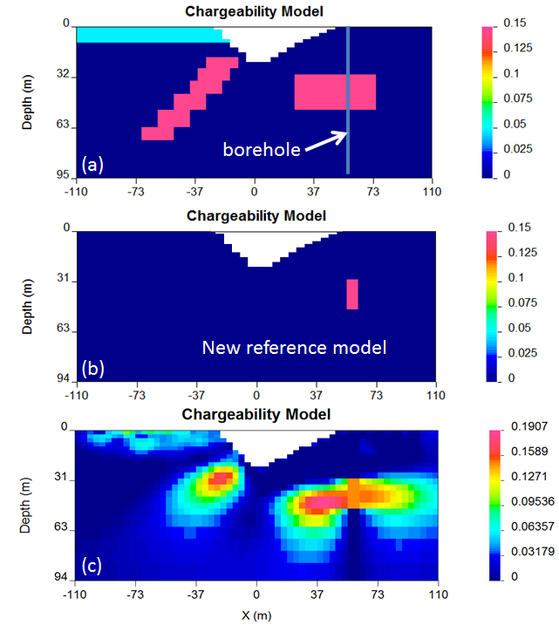

Figure 39. Reference model: cells are inactive, with capability to influence the neighbouring cells.



## Large data set example

In the next example a synthetic data set is introduced, where a Wenner array is combined with a pole-dipole array and covers an 8-km long profile. The synthetic model is a 1000 Ohm m half-space covered by a 50m thick overburden of variable electrical resistivity (200 Ohm m section on the left, followed by 50 Ohm m section in the middle, followed by 500 Ohm m section on the right. The background resistive media is hosting two rectangular bodies at 150m depth each. The prism on the left side is resistive (10,000 Ohm m resistivity) and the prism on the right side is conductive (50 Ohm m) (figure 40a).

For the Wenner array the following configuration was used: number of stations = 400; minimum a-spacing = 80m; maximum a-spacing 1367 m (spreading coefficient: 1.5 to accommodate up to 8 spreads per station). The spreading coefficient in this case is the multiplier used to calculate the increased spread distance between the potential electrodes for each station, given the minimum separation “a”) The total number of data for Wenner array (considering number of stations and all possible separations) was 2610 (figure 40b).

The pole-dipole synthetic survey used a=75m and n=1,10. The current pole was fixed on the right hand side of the array. This resulted in a total number of pole-dipole data of 1005 (figure 40c). The combined Wenner and pole-dipole data set contains 3615 data (figure 40d).

This synthetic model was discretized with a mesh, composed of 17918 cells (including padding), with the smallest cells reaching 30m horizontally and 15m vertically for the core region (depth to 1 km).



Figure 40. Large synthetic data set, combining Wenner and Pole-dipole configurations: (a): synthetic model; (b): synthetic data for Wenner array; (c) synthetic data for Pole-dipole array; (d): synthetic data for combined array.

This synthetic data set was contaminated with 5% Gaussian noise and inverted using L1 measure for model objective function in order to accommodate a more blocky inversion result. The inversion control file is provided below:

OBS LOC_X obs_dc.dat ! Data file

MESH FILE mesh2d.txt

CHIFACT 1

NITER 50

INIT_MOD VALUE 1.E-03

REF_MOD VALUE 1.E-03

INVMODE CG

EKBLOM 1. 1. 1. 1.e-02 1.e-02 1.e-02

BOUNDS VALUE 0.0001 0.02

The inversion converged in 17 iterations (figure41a) and was able to reconstruct all of the features shallower than 500 m depth. This is consistent with the depth of investigation for this survey, based on the sensitivity (figure41b).



Figure 41. (a): Inversion of the large synthetic data set; (b): Depth of investigation based on the sensitivity analysis (threshold = 0.4).

The observed data were compared with the predicted data. The misfit is shown in Figure 42. The predicted data error does not exceed 3.9 standard deviations and overall data misfit is 3597.6.



Figure 42. (a): Observed apparent resistivity (mixed Wenner/Pole-dipole data set); (b): Data misfit, normalized by the standard deviation.

Finally, the parallelization of DCINV2D_V5.0 with OpenMP was analyzed on this example. It was inverted twice using 1 and 12 threads (6 cores with hyper-threading capability) with identical results. Running this example on one thread took 1:15:50.68 of CPU time, while running it on 6 cores (12 threads) resulted in convergence in 0:25:16.86 of CPU time, which is almost a threefold increase in productivity since the last release of DCIP2D.

## Field data example

In the next example the field data set had been collected over the Cluny prospect in Mt. Isa area, Queensland, Australia by MIM Exploration Pty, Ltd (Rutley et al, 2001) . The data were collected using pole-dipole and dipole-pole array configuration. The length of the profiles reaches 2 Km in E - W direction. A total of 10 profiles of DC and IP data were collected with electrode spacing of 50 m. There is topographic disturbance along the profile ranging from 429 to 505 meters in absolute elevation above the mean sea level. The DC and IP data, collected over profile 13700 are shown in (figure 43). The data sets were examined for bad data values (outliers) and based on this criterion 45 data had to be eliminated from the IP inversion.

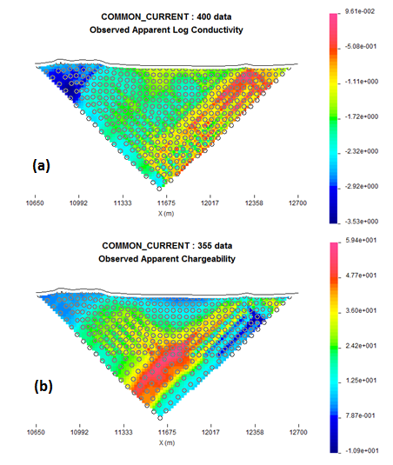

Figure 43. (a): DC data measured along profile 13700 over the Cluny prospect, Australia. (b): IP data measured over the same interval, with reduced number of stations.

Resistivity inversion was carried out using the error assignment of 0.0001 base +5% of the data and constant uniform reference and starting model (100 Ohm m). A default meshing option was used, resulting in 16.8 m wide and 8.33 m high cells in the core region. The control file used for the inversion is provided below with user-defined smallness coefficient and maximum number of iterations set to 50.

OBS LOC_X 2D_13700.dat ! Data file

MESH DEFAULT

TOPO FILE topo.dat ! topography

CHIFACT 1

NITER 50

INIT_MOD VALUE 1.E-02

REF_MOD VALUE 1.E-02

STORE_ALL_MODELS TRUE

ALPHA VALUE 1.E-04 1 1

INVMODE SVD

The results of the inversion (figure 44a) are based on convergence to assigned misfit in 21 iterations (figure 44b). They were compared with the earlier results acquired by DCIP3D code (Rutley et al, 2001) and are shown in figure 44c. The large conductor on the right hand side is a black shale unit. The main geologic structure runs north-south and is essentially perpendicular to the survey line. It is expected therefore that the 2D inversion should produce geologically reasonable results. This is substantiated by comparing this cross-section with a similar cross-section extracted from the 3D inversion (Figure 44a and Figure 44c).

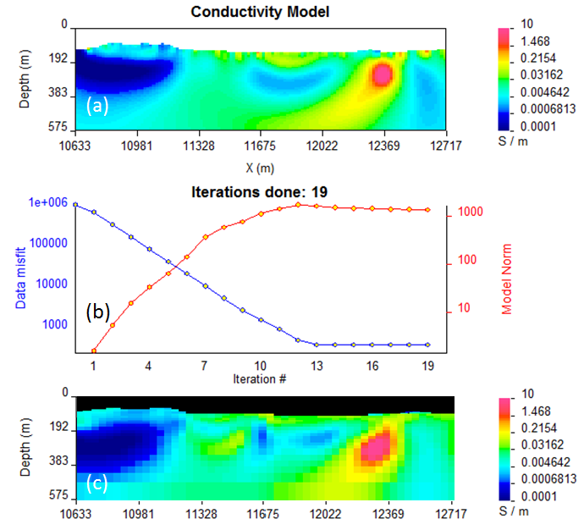

Figure 44. DC inversion over the profile 13700, Cluny prospect, Queensland, Australia; (a): DCIP2D_V5.0 results (b): convergence of the DCIP2D inversion; (c): DCIP3D results, acquired in 2001 over the same profile.

The conductivity models recovered from the DC inversion were further used to carry out the IP inversion. The IP inversion was carried out using the same mesh as for the DC inversion and was further compared to the 3D inversion carried out previously (Rutley et al, 2011). Below is the control file used for the IP inversion:

OBS LOC_X L13700_COMPLETE.dat ! Data file

TOPO FILE topo.dat ! topography

CHIFACT 1

NITER 50

INIT_MOD VALUE 1.E-07

REF_MOD VALUE 1.E-07

STORE_ALL_MODELS TRUE

ALPHA VALUE 1.E-04 1. 1.

COND FILE DCINV2D.CON

INVMODE SVD

MESH FILE DCINV2D.MSH

The results of the inversion were once again compared to the corresponding 3D IP inversion (Rutley et al, 2001) and are shown in figure 45.

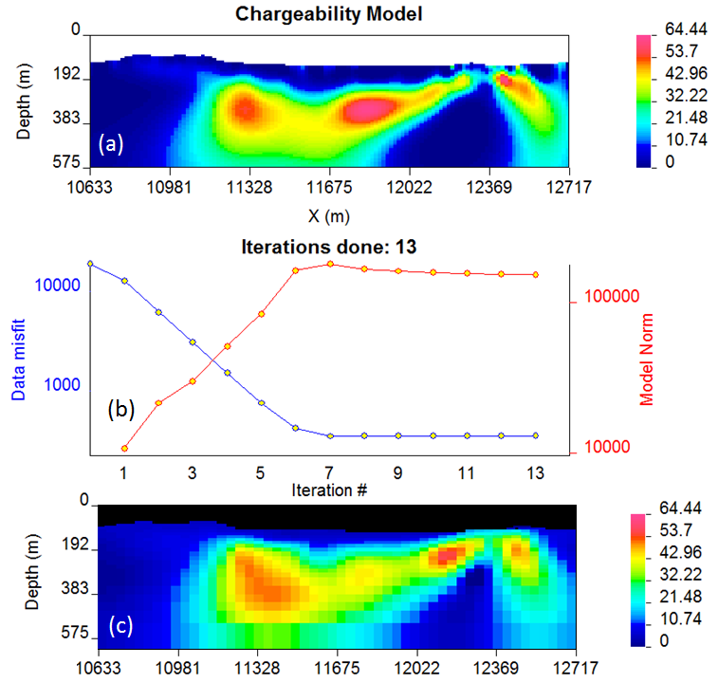

Figure 45. IP inversion over the profile 13700 (a): IPINV2D_V5.0 results; (b): Convergence of the DCIP2D inversion; (c):DCIP3D results, acquired in 2001 over the same profile.

The predicted data from the inversions has been verified against the measured data and plotted in figure 46 and figure 47.

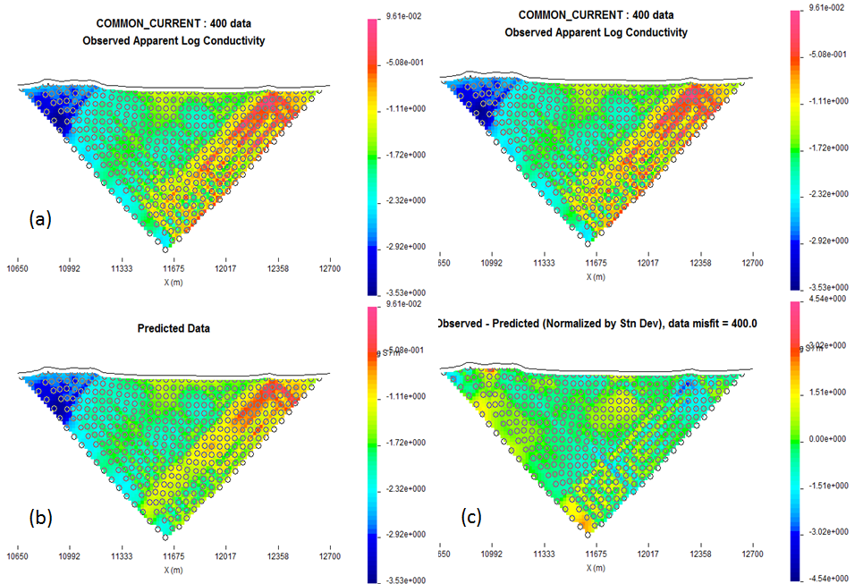

Figure 46 (a): Observed data from DCINV2d line 13700 (b): Predicted data from line 13700 (c): Data misfit normalized by standard deviation.

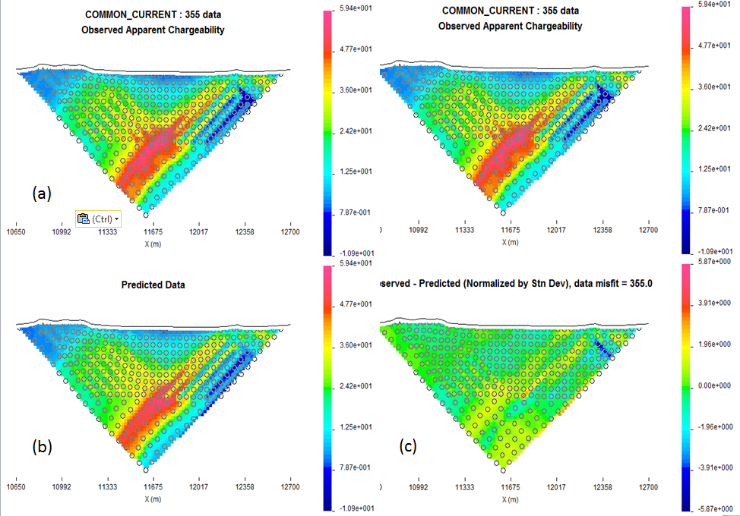

Figure 47 (a): Observed data from IPINV2d line 13700 (b): Predicted data from line 13700 (c): Data misfit normalized by standard deviation.

Both inversions (DC and IP) have successfully converged and the misfit does not exceed 5 standard deviations, which is one of the criterions of successful inversions. Another criterion is the verification of the 2D results against the 3D results, which show very comparable results.

## Borehole examples

The next example is based on synthetic borehole DC data, where the simulated data are

1. Surface data simulated using dipole-dipole configuration
2. Borehole data simulated using larger dipole with one transmitter electrode placed in the borehole
3. Combination of surface and borehole data simulation

The synthetic data were generated using a 2D model (figure 48) that contains a 25 m thick overburden of 100 Ohm m over a 1000 Ohm m halfspace. A 1 Ohm m prism is located buried so that its top is 100 meters below the surface. The prism is 100m x 100m. The model was discretized onto a 6869 cell mesh (104 horizontal by 66 vertical cells. Smallest cell equals 10m by 5 m). The locations of two boreholes are shown in the figure.

## 

Figure 48. Synthetic model used for the borehole example.

The first synthetic data set is surface-only dipole-dipole array. Electrodes are located every 25 m within the region (0,800m) and each dipole-dipole survey used n=1,15. A total of 30 transmitter locations were used. The total number of data is 345. The data were contaminated with 5% Gaussian noise and inverted with a chi-factor of 1 (see control input file configuration provided below). The inversion has converged in 14 iterations. The results of the inversion of surface data are presented in Figure 49.

OBS LOC_XZ dc_surface.dat

MESH FILE mesh2d.txt

INVMODE CG

REF_MOD VALUE 0.001



Figure 49. Inversion of the synthetic surface dipole-dipole data only

Next the same conductivity model was used to simulate a synthetic borehole data set for two boreholes located at X=200 and X=500. Electrodes were spaced every 25 m down each borehole to a maximum depth of 250m. The transmitter electrodes are located in the opposite boreholes in all possible configurations. The schematic diagram illustrating this survey configuration is shown in figure 50**.**  This resulted in a total of 121 transmitters. Each transmitter configuration is a common-current source for up to 20 receiver dipoles in both boreholes. The total number of data is 2200. The simulated data set was contaminated by 5% Gaussian noise and inverted using same inversion parameters as the surface data set. The results are shown in figure 51.

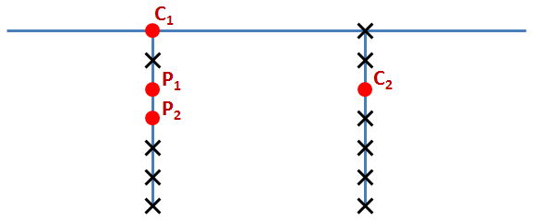

Figure 50. Schematic survey configuration for the synthetic borehole example. Red dots mark the electrode positions.

Further, the data sets were combined to accommodate 151 transmitter locations and 2545 data. The combined data set was inverted with the same parameters as each individual data set with the results shown in figure 52. As it is evident from these three inversions, the surface geometry alone has strong limitations in depth resolution, while the borehole configuration has limitations in near-surface recovery and it is the combination of the two surveys, which allows better recovery of the conductivity.



Figure 51. Inversion of the synthetic borehole data set only.



Figure 52. Inversion results from the combined surface-borehole data set.

Further, the inversion was constrained using a weighting matrix with small weights for the vertical interface at the depth of 25 meters, ensuring a sharper contrast across this boundary and large weights assigned to all horizontal interfaces up to the depth of 25 meters, ensuring a smooth transition of electrical properties in this direction. This weighting matrix is designed, assuming there is a-priori knowledge about the overburden and defines the latter as a horizontal (laterally smooth) structure with abrupt transition in the vertical direction. The control file used for this inversion is shown below. The result of the inversion is shown in figure 53.

OBS LOC_XZ dc_surface.dat

MESH FILE mesh2d.txt

INVMODE CG

REF_MOD VALUE 0.001

WEIGHT weights.txt

It is evident from figure 53, that not only did the weighting function assure clean resolution of overburden, but it also helped to remove some noise from the background, if compared with figure 52.



Figure 53. Inversion of the combined data set using weighting function constraint.

The next step was to simulate a scenario, when the down-hole conductivity data is available. This was done using the inactive cells constraint. Figure 54a shows the new reference model with fixed cells along X=200 and X=500 to the depth of 250 m. The data were inverted using inactive cells constraint with no ability to affect the neighbouring cells (Figure 54b), with ability to interfere with the neighbours (Figure 54c) and in combination with the weighting matrix (Figure 54d).

OBS LOC_XZ obs_dc_n.dat

MESH FILE mesh2d.txt

INVMODE CG

REF_MOD FILE ref.con

ACTIVE_CELLS active.txt

Finally, the area of inactive cells was extended, simulating a scenario, when a-priori information suggests that the anomalous conductivity lies between the two boreholes. The final control file used for inverting data under these constraints is presented below:

OBS LOC_XZ obs_dc_n.dat

MESH FILE mesh2d.txt

INVMODE CG

REF_MOD FILE ref.con

ACTIVE_CELLS active.txt

WEIGHT weights.txt

The results of the final inversion are presented in Figure 55.



Figure 54. (a): The new reference model, accommodating the inactive cells. (b): the inversion with inactive cells not influencing their neighbours. (c): Inversion with inactive cells influencing their neighbours. (d): Inversion with both: inactive cells and weighting function.

## 

Figure 55. (a): The reference model with extended region of inactive cells. (b): Inversion results, using weighting matrix and inactive cells constraints.

## References

Calamai, P.H., More, J.J.,1987, Projected Gradient methods for linearly constrained problems, University of Waterloo.

Rutley, A, Oldenburg, D.W., Shekhtman, R., 2001, 2-D and 3-D IP/Resistivity inversion or the interpretation of Isa-style targets, Expanded abstract submitted to ASEG 15-th Geophysical Conference and Exhibition, August, 2001, Brisbane, Australia.